University of Seville  
 School of Computer Engineering

**Performance Report**



Software engineering  
Design and testing 2

2018 – 2019

06/04/2019

Group 26

**Index**

1. Observations 6

2. Package 6

Create 6

Edit LUIS 7

Delete 9

Conclusion 11

3. Evaluation 12

Create 12

Delete 13

Conclusion 15

4. Message 15

Send 15

Move 17

Copy 19

Delete 21

Conclusion 23

5. Message box 23

Create 23

Edit 25

Delete 27

Conclusion 29

6. Social profile 29

Create 29

Edit 31

Delete 33

Conclusion 35

7. Dashboard 36

Show dashboard and launch all process 36

Conclusion 38

8. Category 38

Create 38

Edit 40

Delete 41

Conclusion 43

9. Request 44

Create 44

Edit 45

Delete 47

Conclusion 48

10. TraverseTown 49

Create 49

Edit 50

Delete 52

Conclusion 54

11. Issue 55

Create 55

Delete 56

Conclusion 58

12. Town 58

Create 58

Edit 60

Delete 62

Conclusion 63

13. Comment 64

Create 64

Conclusion 65

14. Configuration 66

Display and edit 66

Conclusion 67

15. Finder 68

Search 68

Conclusion 69

16. Offer 70

Create/Edit 70

Delete 71

Conclusion 73

17. Curricula 74

Create a curriculum 74

Edit a curriculum 75

Delete a curriculum 77

18. Records (Professional and Miscellaneous record) 78

Create Miscellaneous Record 78

Create Professional Record 80

Edit a Miscellaneous Record 82

Edit a Professional Record 83

Delete a professional record 85

Delete a miscellaneous data 86

Conclusion 88

19. Actor 88

Create 88

Edit 89

Delete 91

Conclusion 92

20. Vehicle 92

Create 92

Edit 94

Delete 95

Conclusion 97

21. Solicitation 97

Create 97

Edit 99

Delete 100

Conclusion 102

22. Sponsorship 102

Create 102

Edit 104

Delete 105

Conclusion 107

23. Fare 107

Create 107

Edit 108

Delete 110

Conclusion 111

24. TODO DE AQUI PABAJO SE BORRA **¡Error! Marcador no definido.**

25. Position **¡Error! Marcador no definido.**

Create **¡Error! Marcador no definido.**

Edit **¡Error! Marcador no definido.**

Delete **¡Error! Marcador no definido.**

Conclusion **¡Error! Marcador no definido.**

26. Mess **¡Error! Marcador no definido.**

Search by tags, list by that tag and display a mess **¡Error! Marcador no definido.**

Send a message **¡Error! Marcador no definido.**

Delete a message **¡Error! Marcador no definido.**

Send a broadcast mess **¡Error! Marcador no definido.**

Conclusion **¡Error! Marcador no definido.**

27. Dashboard **¡Error! Marcador no definido.**

Display the dashboard and set the spammers **¡Error! Marcador no definido.**

Conclusion **¡Error! Marcador no definido.**

28. Configuration **¡Error! Marcador no definido.**

Display the configuration and edit it **¡Error! Marcador no definido.**

Conclusion **¡Error! Marcador no definido.**

29. Problem **¡Error! Marcador no definido.**

Create **¡Error! Marcador no definido.**

Edit **¡Error! Marcador no definido.**

Delete **¡Error! Marcador no definido.**

Conclusion **¡Error! Marcador no definido.**

30. Finder **¡Error! Marcador no definido.**

Search and clear **¡Error! Marcador no definido.**

Conclusion **¡Error! Marcador no definido.**

31. Curricula **¡Error! Marcador no definido.**

Create a curriculum **¡Error! Marcador no definido.**

Edit a curriculum **¡Error! Marcador no definido.**

Delete a curriculum **¡Error! Marcador no definido.**

32. Records (Professional and Miscellaneous record) **¡Error! Marcador no definido.**

Create Miscellaneous Record **¡Error! Marcador no definido.**

Create Professional Record **¡Error! Marcador no definido.**

Edit a Miscellaneous Record **¡Error! Marcador no definido.**

Edit a Professional Record **¡Error! Marcador no definido.**

Delete a professional record **¡Error! Marcador no definido.**

Delete a miscellaneous data **¡Error! Marcador no definido.**

Conclusion **¡Error! Marcador no definido.**

33. Social profile **¡Error! Marcador no definido.**

Create **¡Error! Marcador no definido.**

Edit **¡Error! Marcador no definido.**

Delete **¡Error! Marcador no definido.**

Conclusion **¡Error! Marcador no definido.**

34. Actor **¡Error! Marcador no definido.**

Create **¡Error! Marcador no definido.**

Edit **¡Error! Marcador no definido.**

Delete **¡Error! Marcador no definido.**

Conclusion **¡Error! Marcador no definido.**

35. Vehicle **¡Error! Marcador no definido.**

Create **¡Error! Marcador no definido.**

Edit **¡Error! Marcador no definido.**

Delete **¡Error! Marcador no definido.**

Conclusion **¡Error! Marcador no definido.**

36. Solicitation **¡Error! Marcador no definido.**

Create **¡Error! Marcador no definido.**

Edit **¡Error! Marcador no definido.**

Delete **¡Error! Marcador no definido.**

Conclusion **¡Error! Marcador no definido.**

37. Sponsorship **¡Error! Marcador no definido.**

Create **¡Error! Marcador no definido.**

Edit **¡Error! Marcador no definido.**

Delete **¡Error! Marcador no definido.**

Conclusion **¡Error! Marcador no definido.**

38. Fare **¡Error! Marcador no definido.**

Create **¡Error! Marcador no definido.**

Edit **¡Error! Marcador no definido.**

Delete **¡Error! Marcador no definido.**

Conclusion **¡Error! Marcador no definido.**

39. Conclusion of the performance **¡Error! Marcador no definido.**

# Observations

We have considered that our performance tests were valid as long as they were lasting between 2’5 and 3 seconds and no error was showed.

# Package

## Create

Sequence:

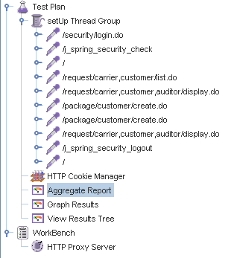

Aggregate Report:

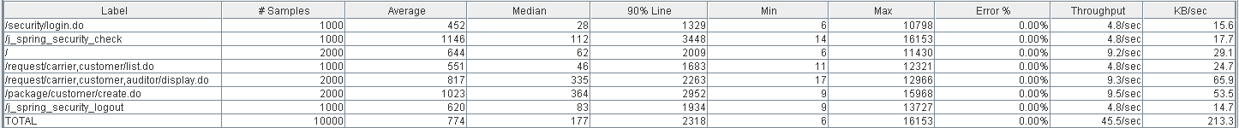



Thread properties:

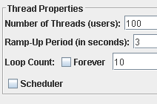

Graph Results:

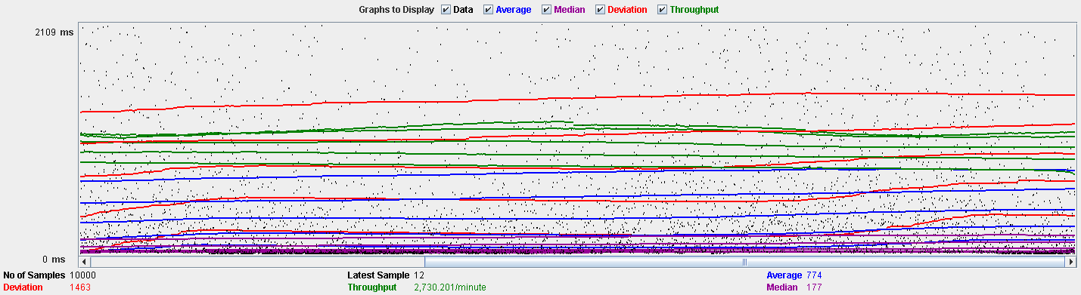

Performance Results:

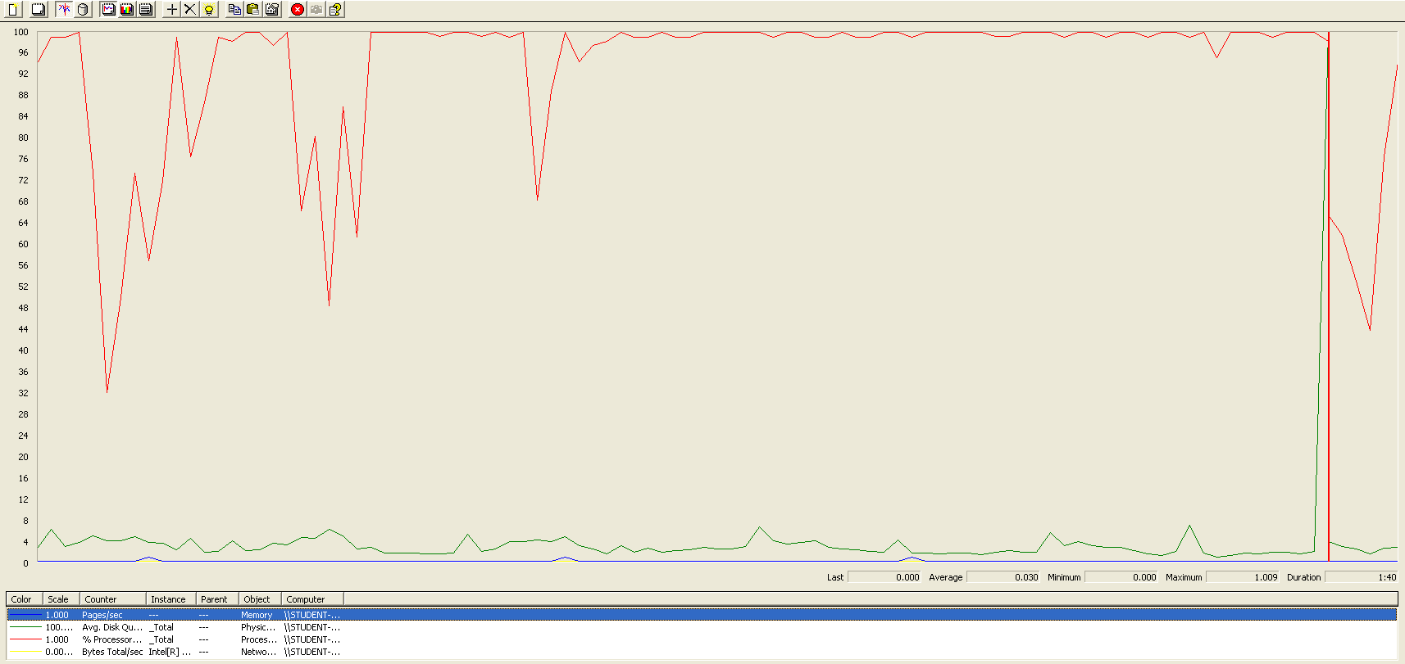

The CPU is always being used while the disk usage is barely noticeable..

## Edit

Sequence:

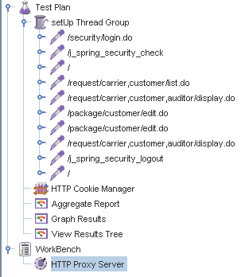

Aggregate Report:

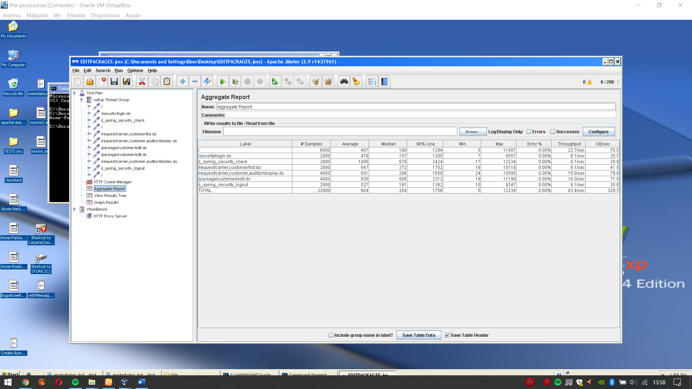

Thread properties:

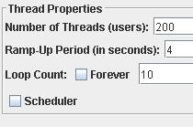

Graph Results:

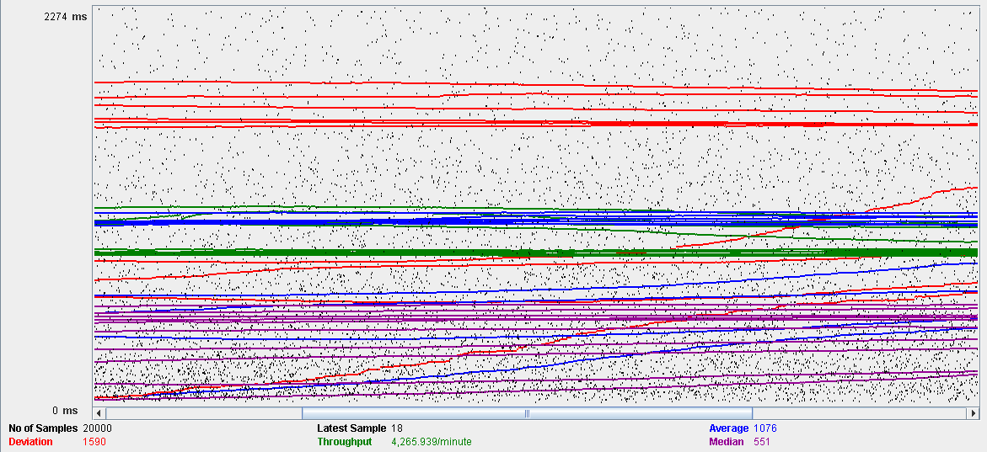

Performance Results:

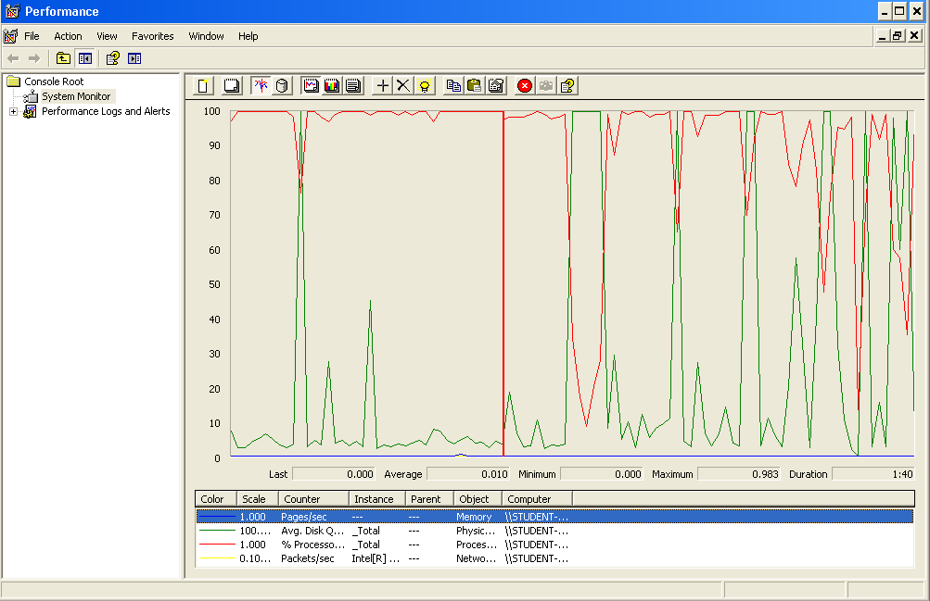

Again we can see that the CPU is always being used while the disk usage shows some periodic peaks.

## Delete

Sequence:

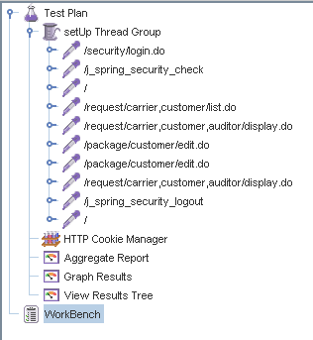

Aggregate Report:

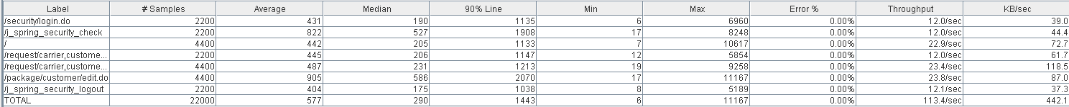



Thread properties:

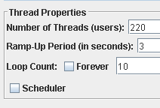.

Graph Results:

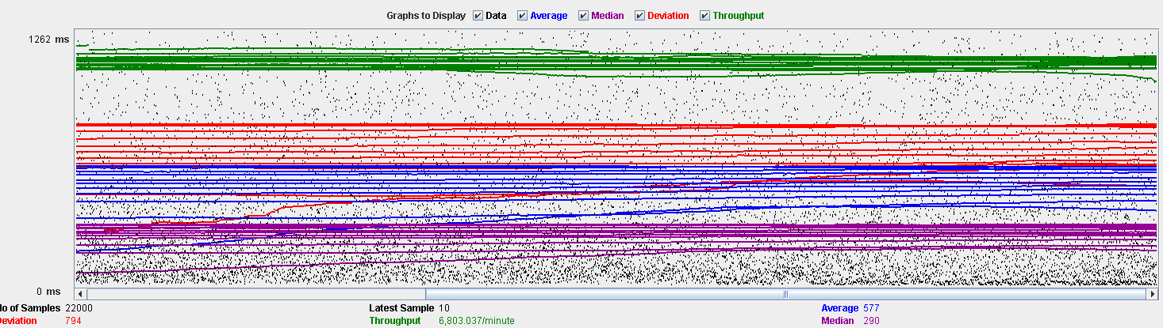

Performance Results:

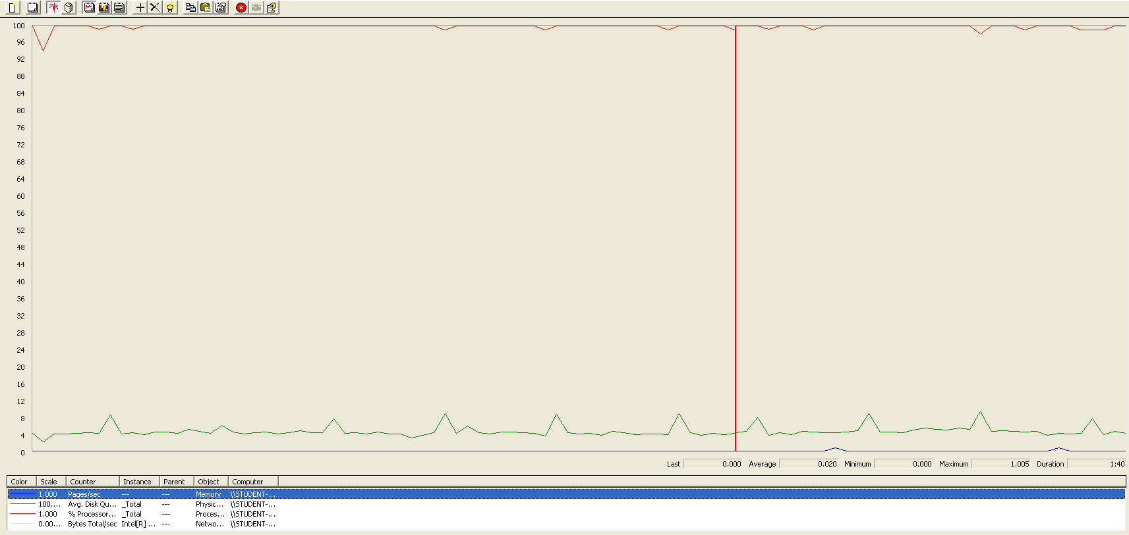

Again we can see that the CPU is always being used while the disk usage shows some peaks. The times are a little bit lower in order to avoid errors.

## Conclusion

The test was performed using:

CPU: i7 6700hq (2 cores in the virtual machine)

RAM: 4 GB (virtual machine)

For this use case we can say that the limitation occurs during the creation process, being the maximum of concurrent users 100. The times during the delete process did not reach the 3 seconds mark in order to avoid errors.

# Evaluation

## Create

Sequence:

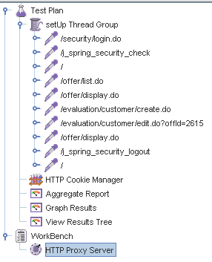

Aggregate Report:

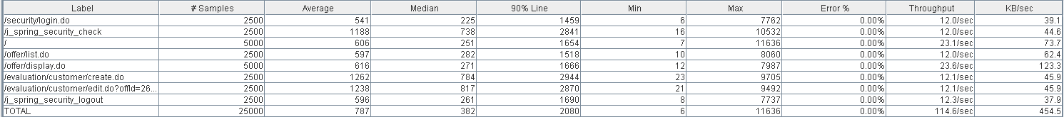



Thread properties:

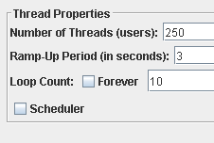

Graph Results:

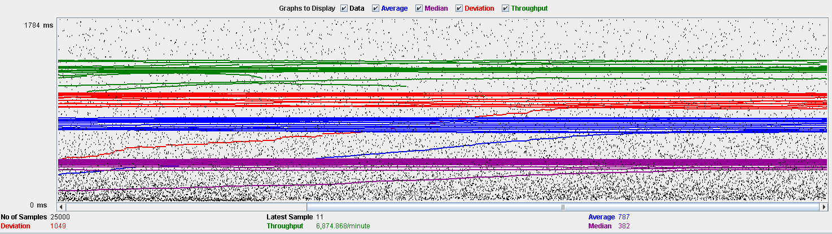

Performance Results:

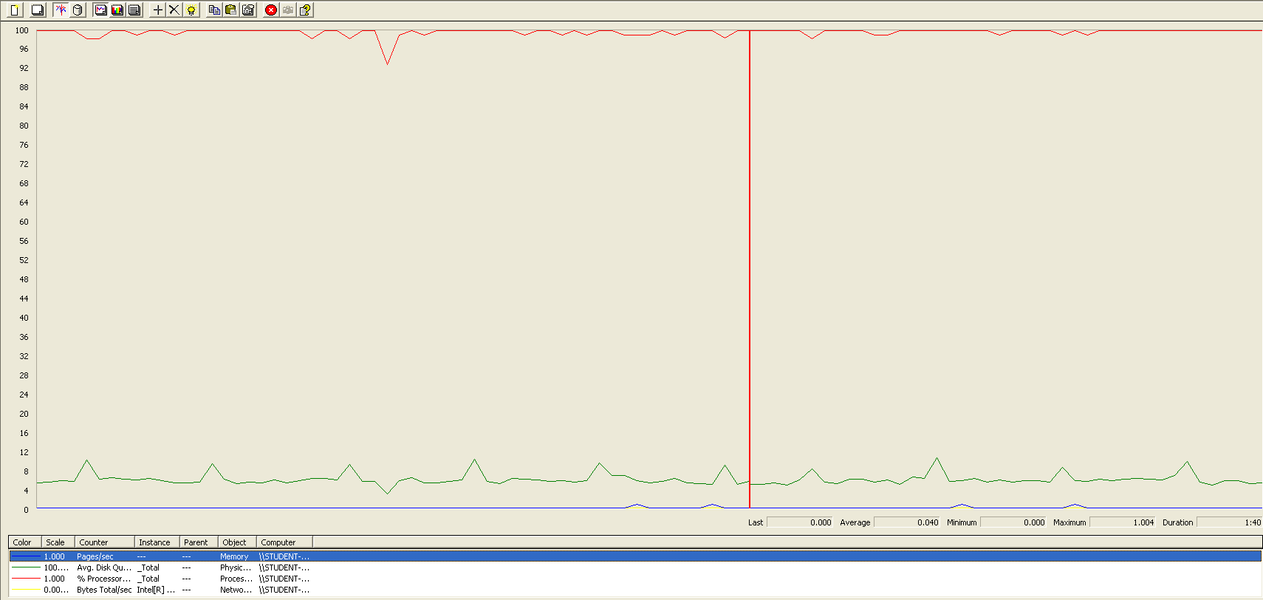

The CPU is always being used while the disk usage is barely noticeable.

## Delete

Sequence:

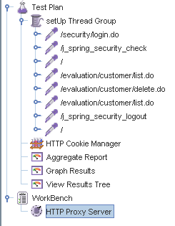

Aggregate Report:





Thread properties:

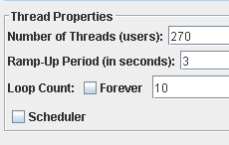

Graph Results:

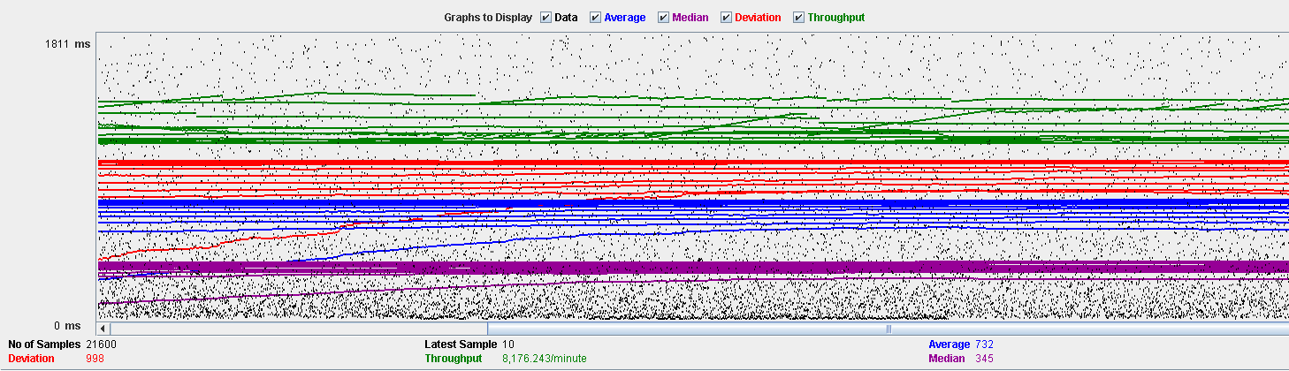

Performance Results:

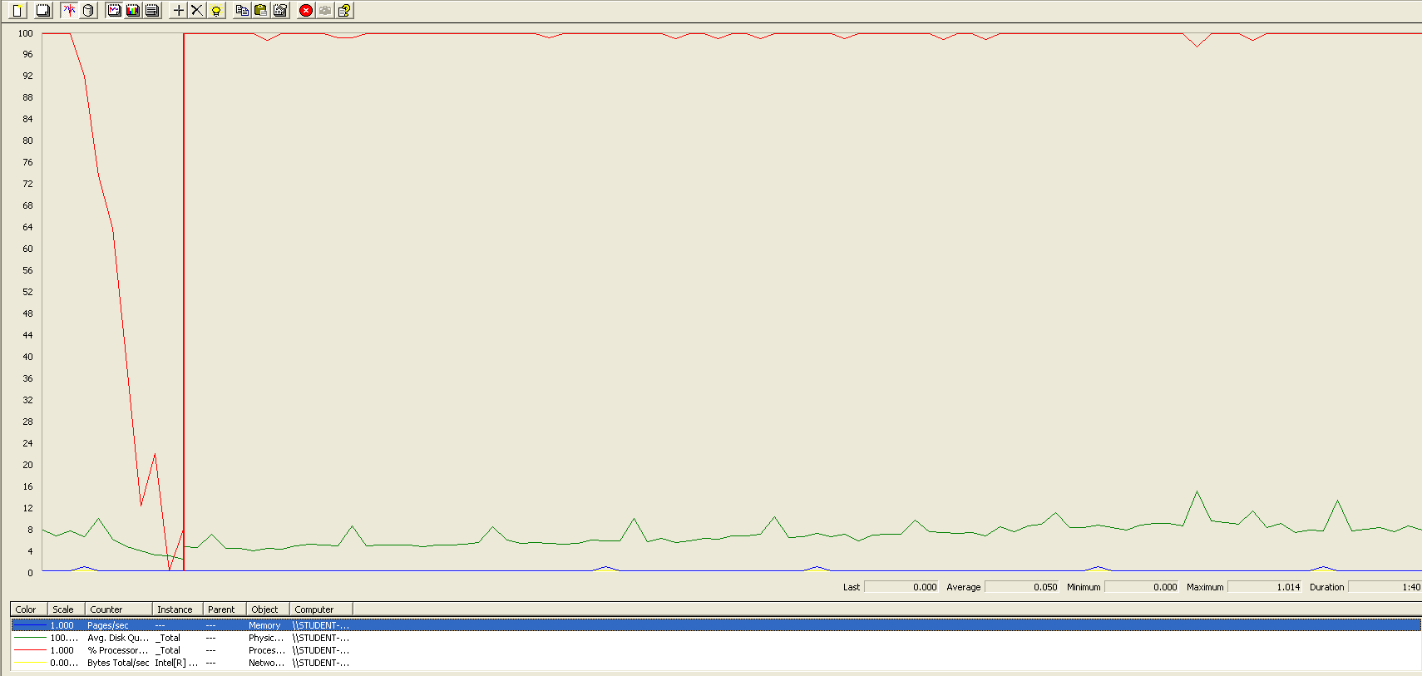

The CPU is always being used while the disk usage is barely noticeable.

## Conclusion

The test was performed using:

CPU: i7 7700hq (2 cores in the virtual machine)

RAM: 4 GB (virtual machine)

For this use case we can say that the limitation occurs during the creation process, being the maximum of concurrent users 250.

# Message

## Send

Sequence:

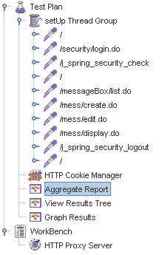

Aggregate Report:

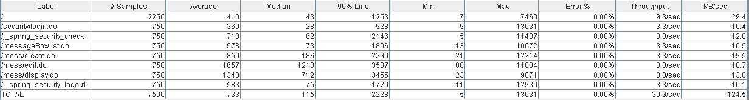

Thread properties:

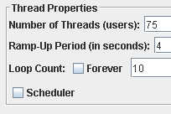

Graph Results:

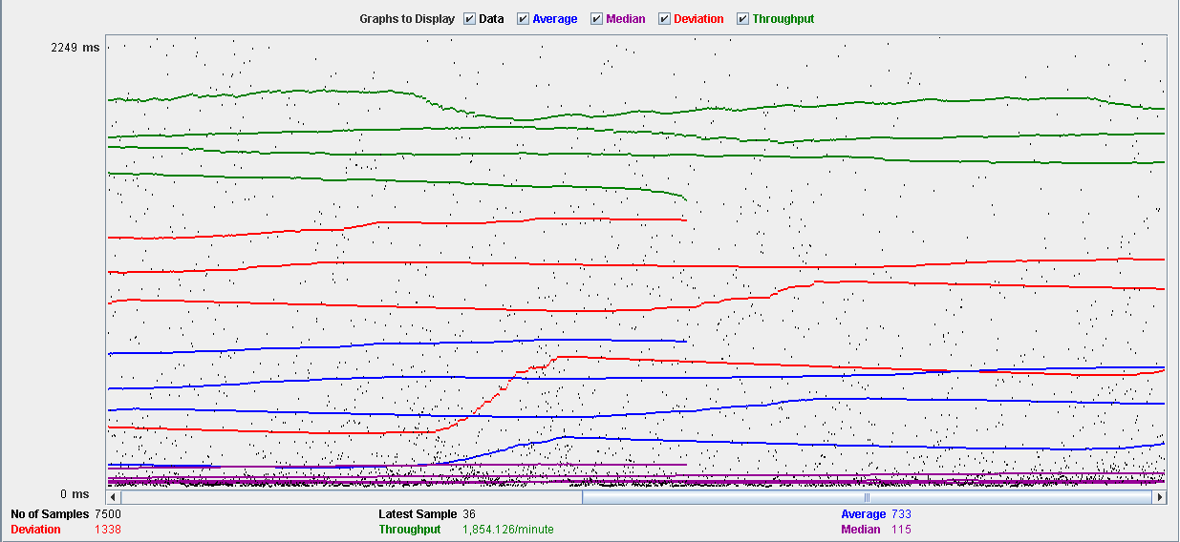

Performance Results:

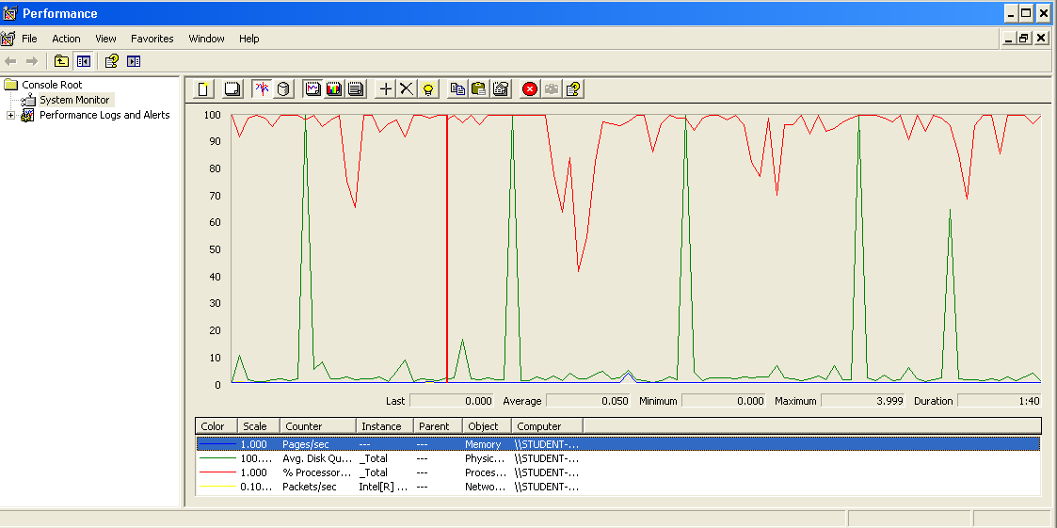

The CPU is always being used and some picks of physical disk.

## Move

Sequence:

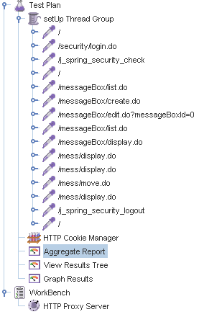

Aggregate Report: 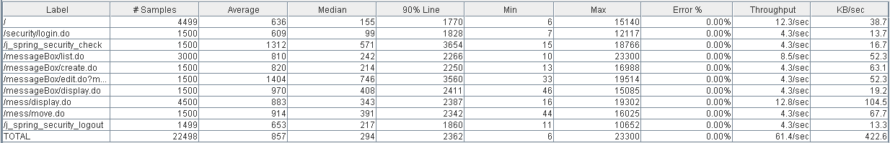



Thread properties:

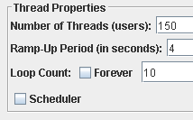

Graph Results:

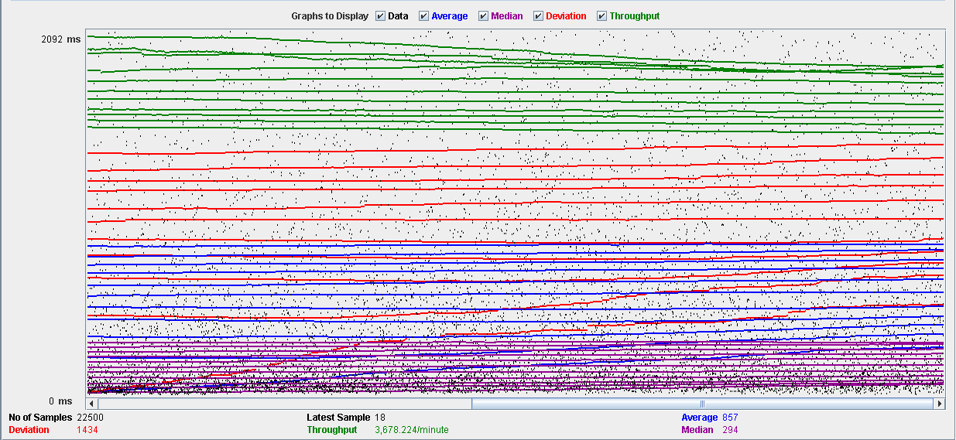

Performance Results:

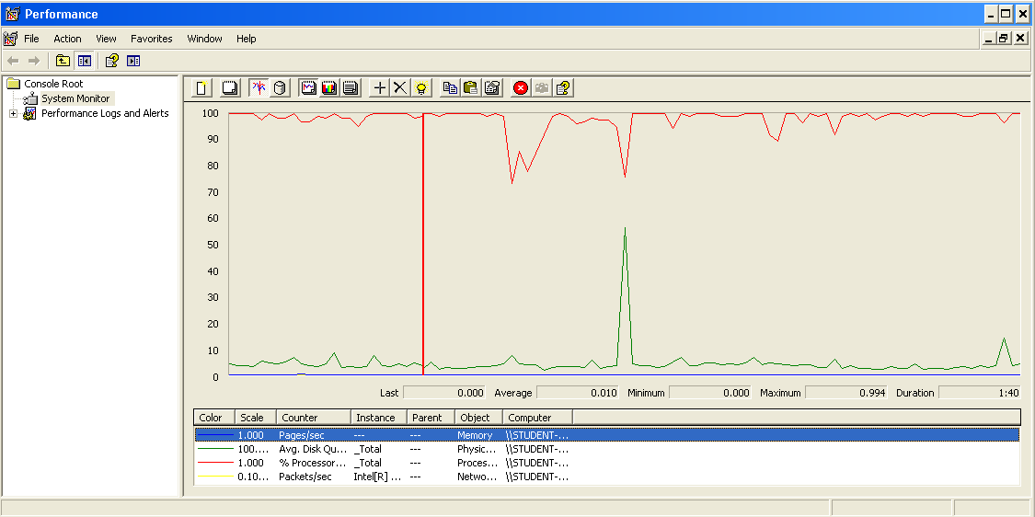

The CPU is always being used and some picks of physical disk.

## Copy

Sequence:

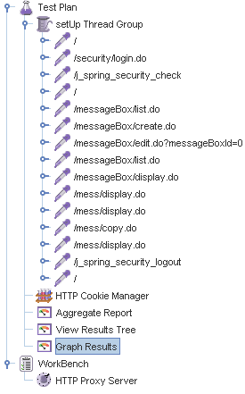

Aggregate Report: 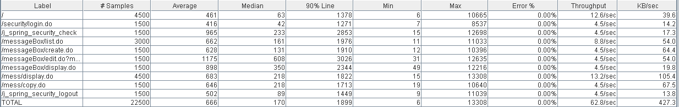



Thread properties:



Graph Results:

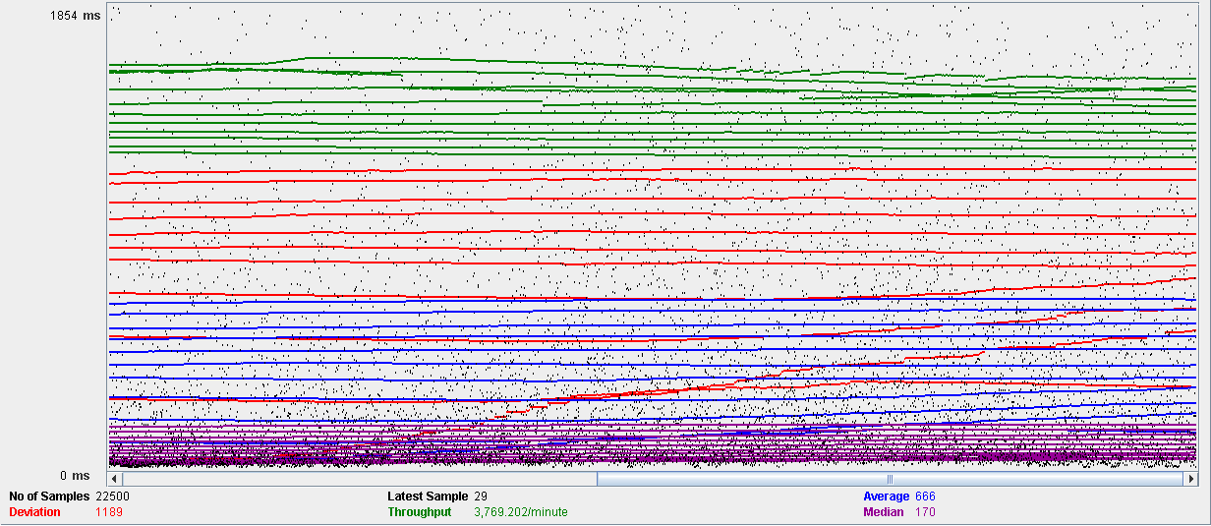

Performance Results:

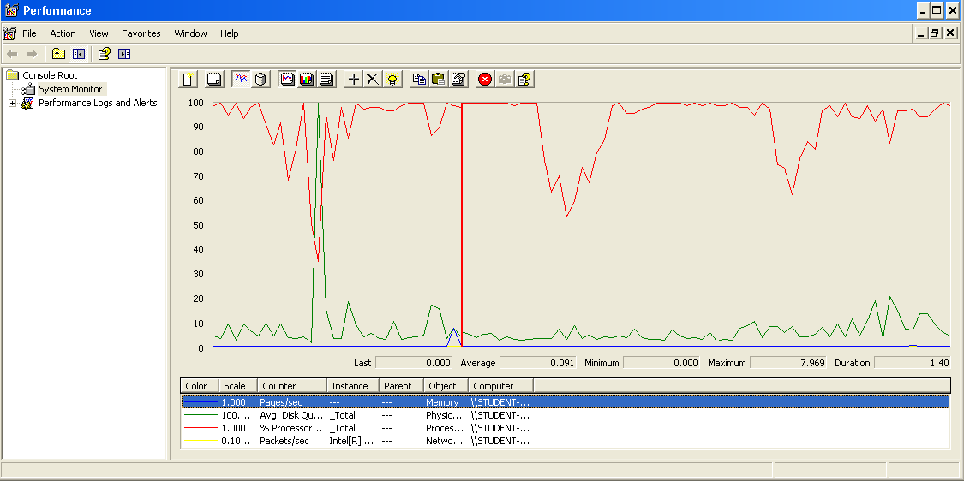

The CPU is always being used and a pick of physical disk.

## Delete

Sequence:

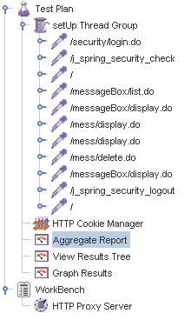

Aggregate Report: 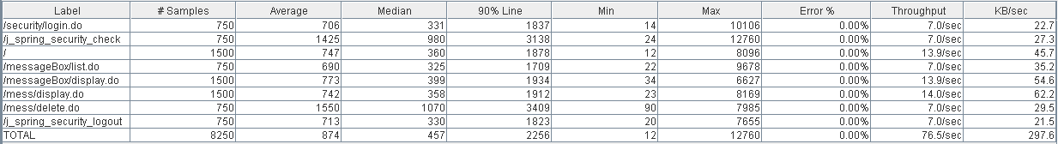



Thread properties:



Graph Results:

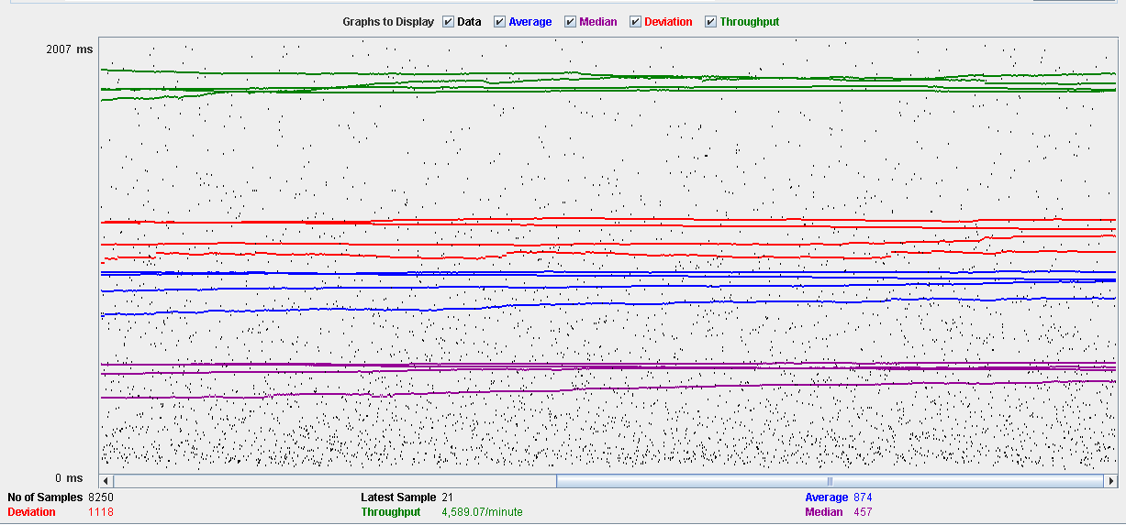

Performance Results:

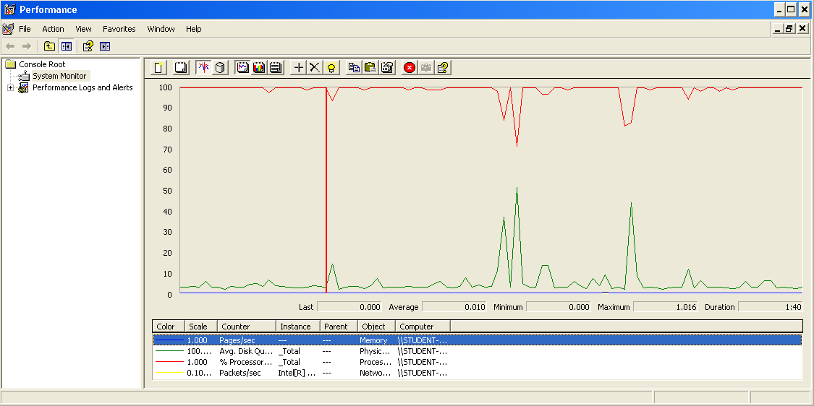

The CPU is always being used while the physical disk has some picks.

## Conclusion

The test was performed using:

CPU: i7 7700hq (2 cores in the virtual machine)

RAM: 2 GB (virtual machine)

For this use case we can say that the limitation occurs during the send and delete process, being the maximum of concurrent users 75.

# Message box

## Create

Sequence:

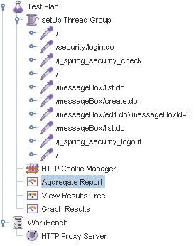

Aggregate Report:

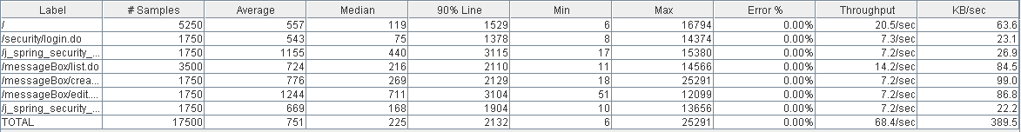

Thread properties:

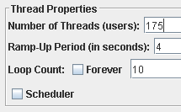

Graph Results:

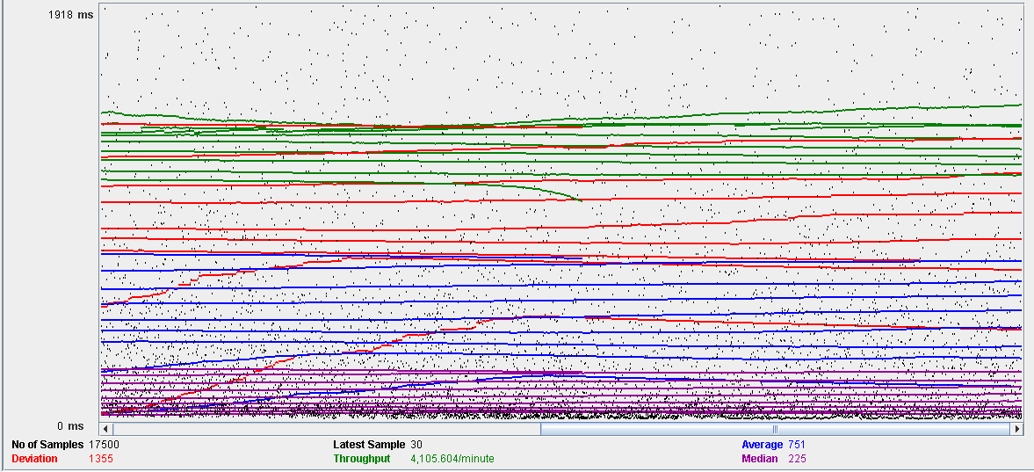

Performance Results:

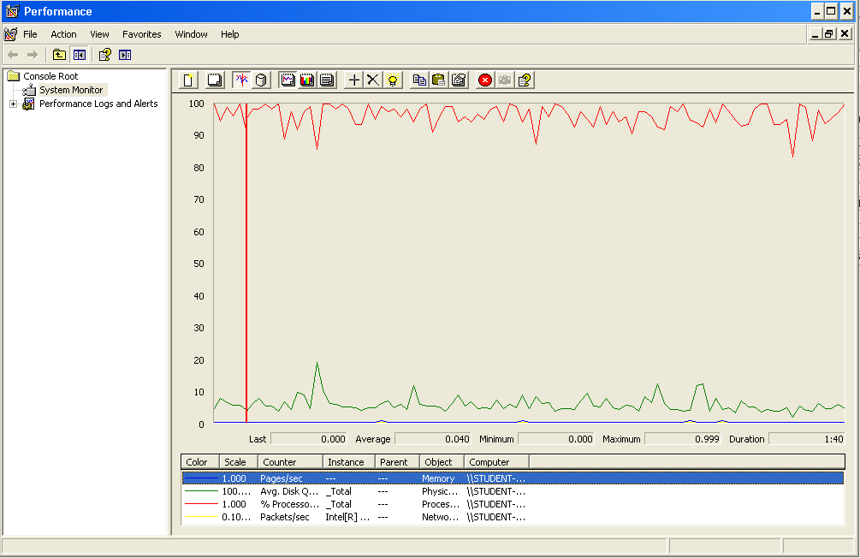

The CPU is always being used and physical disk usage is barely noticeable.

## Edit

Sequence:

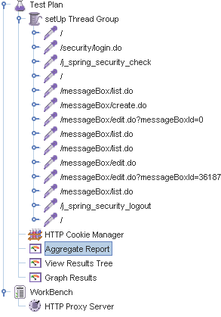

Aggregate Report: 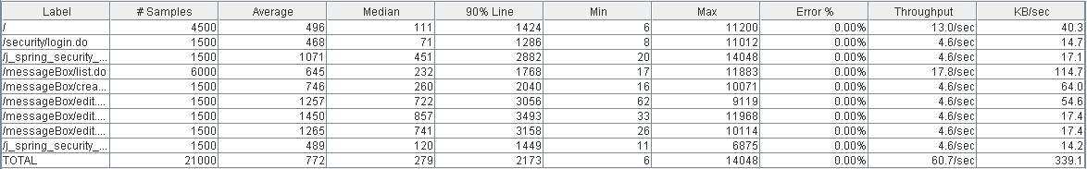



Thread properties:



Graph Results:

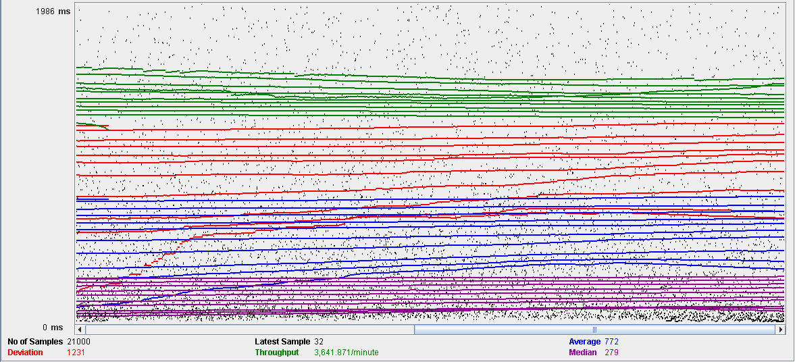

Performance Results:

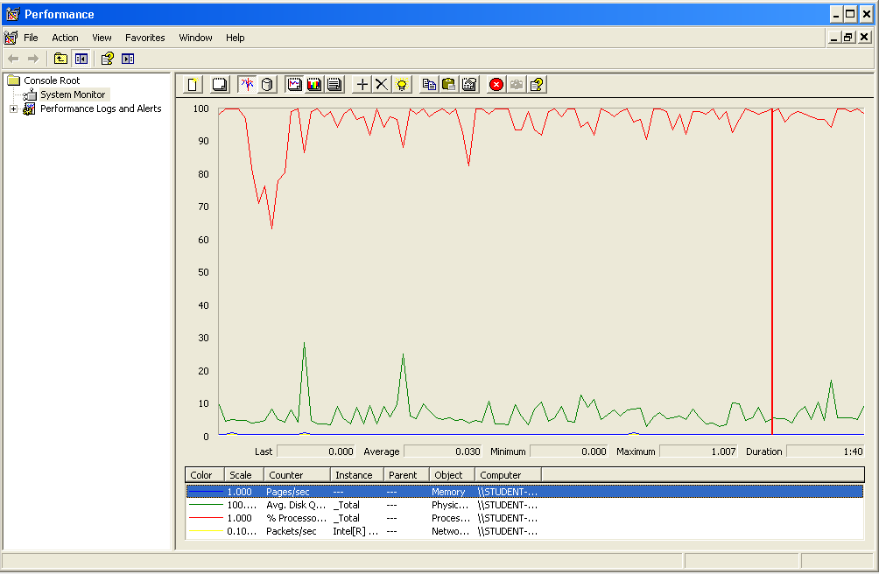

The CPU is always being used and small picks of physical disk

## Delete

Sequence:

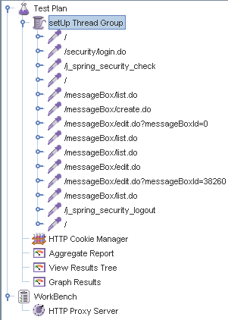

Aggregate Report: 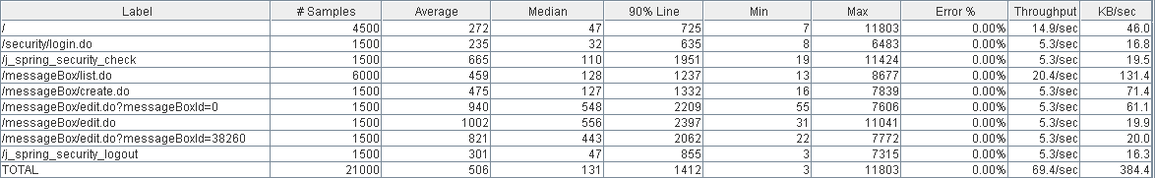



Thread properties:



Graph Results:

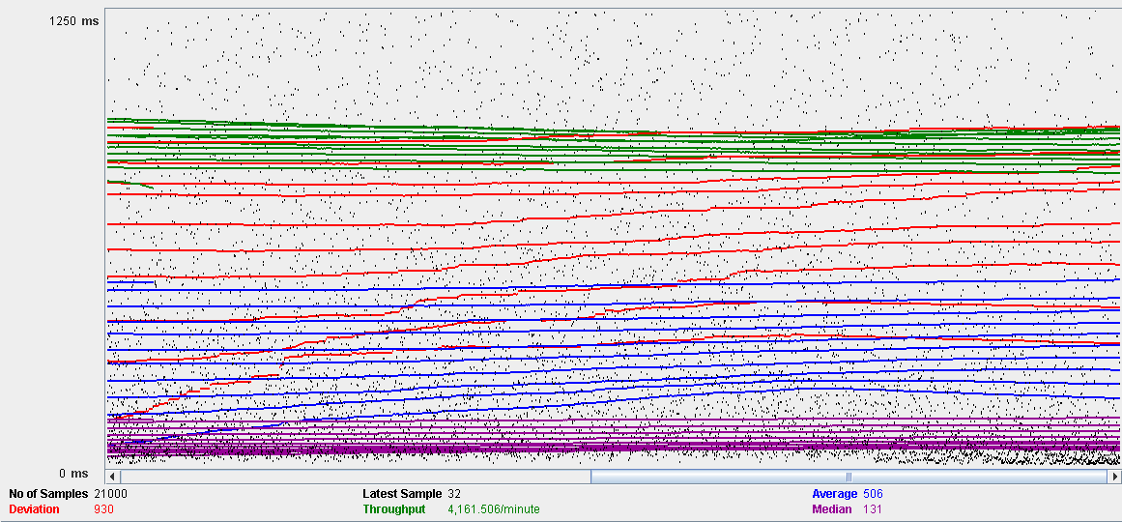

Performance Results:

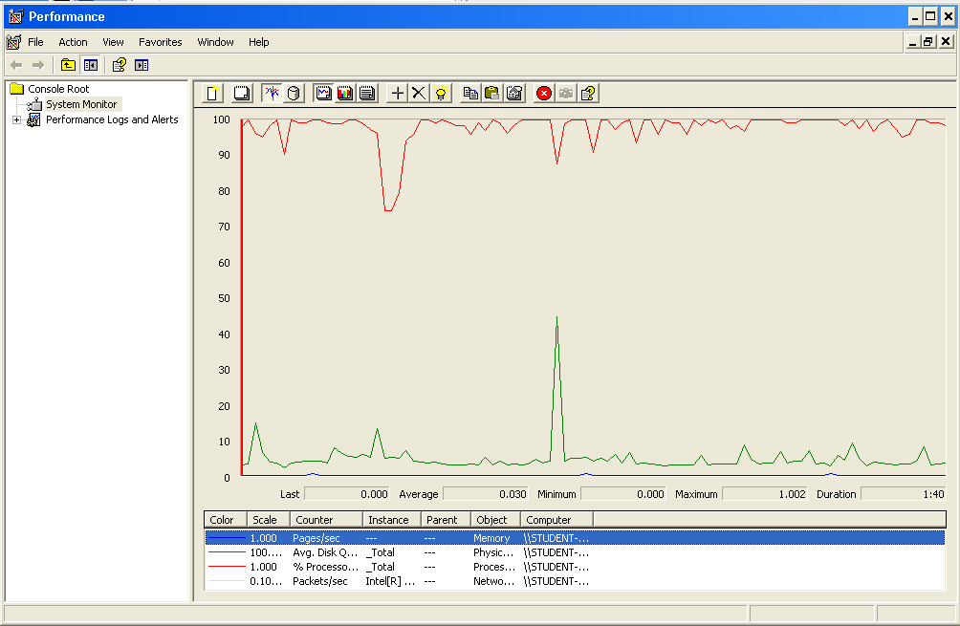

The CPU is always being used while the memory has some picks.

## Conclusion

The test was performed using:

CPU: i7 7700hq (2 cores in the virtual machine)

RAM: 2 GB (virtual machine)

For this use case we can say that the limitation occurs during the edition process, being the maximum of concurrent users 150.

# Social profile

## Create

Sequence:

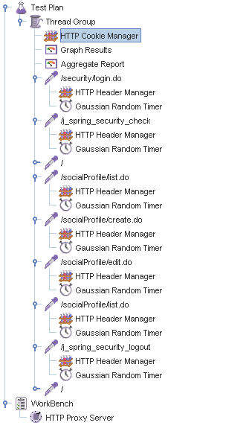

Aggregate Report:

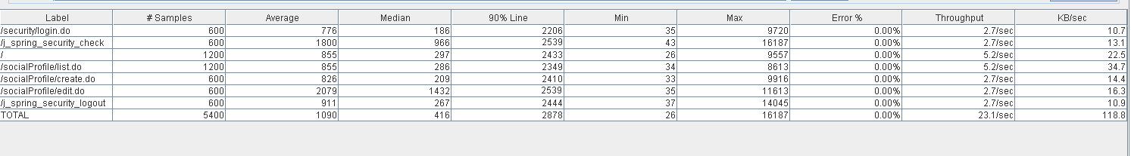

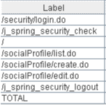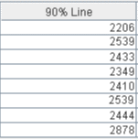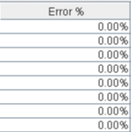

Thread properties:

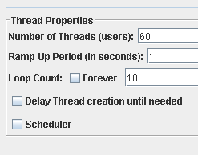

Graph Results:

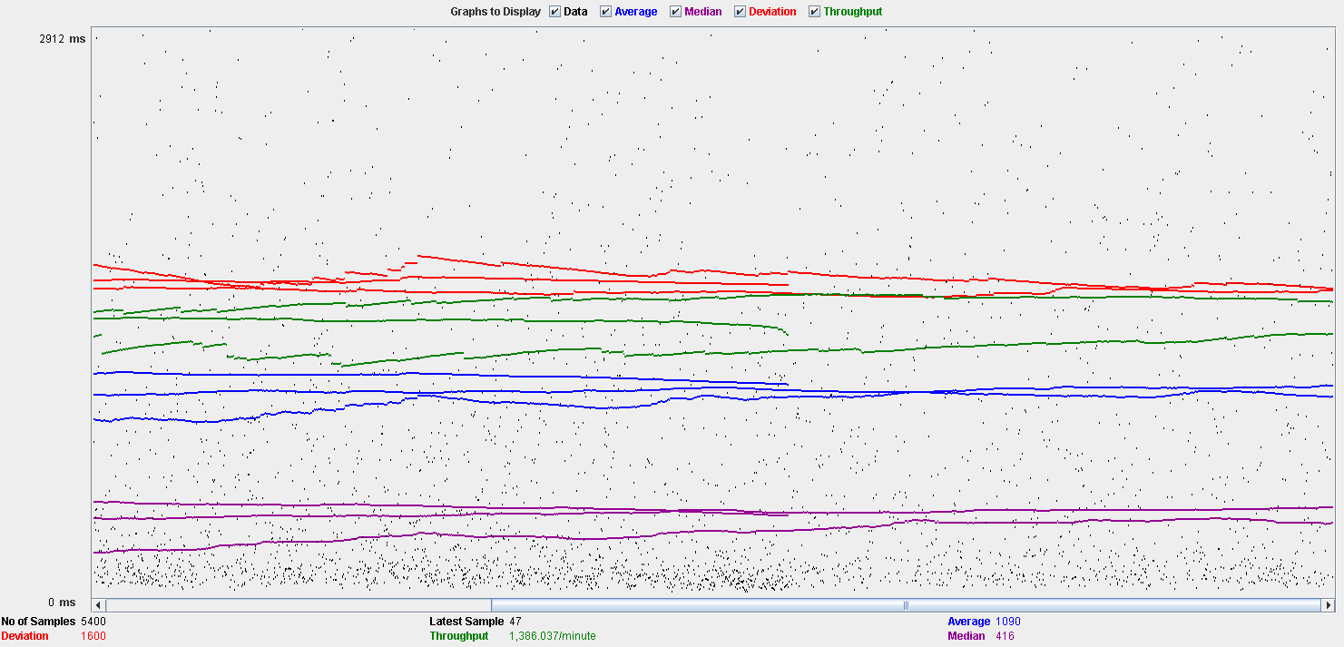

Performance Results:

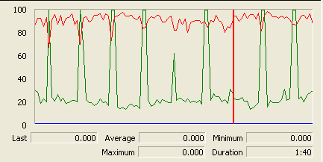

The CPU is always being used while the disk show many peaks.

## Edit

Sequence:

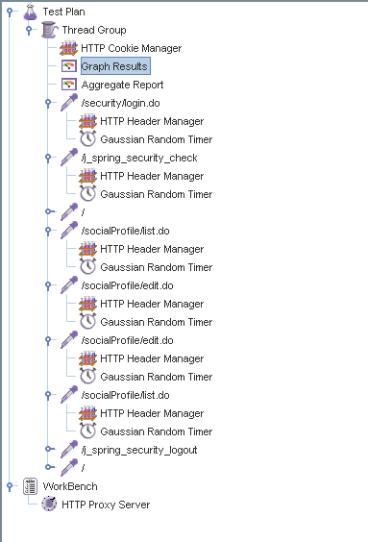

Aggregate Report:

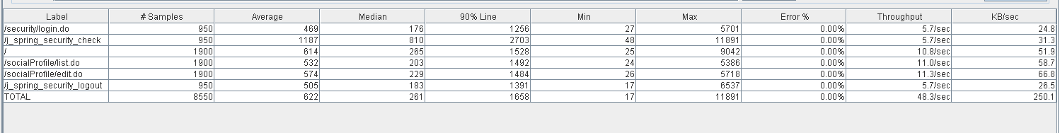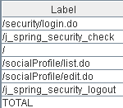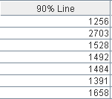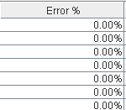

Thread properties:

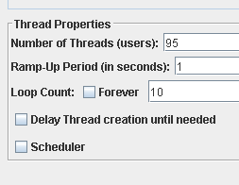

Graph Results:

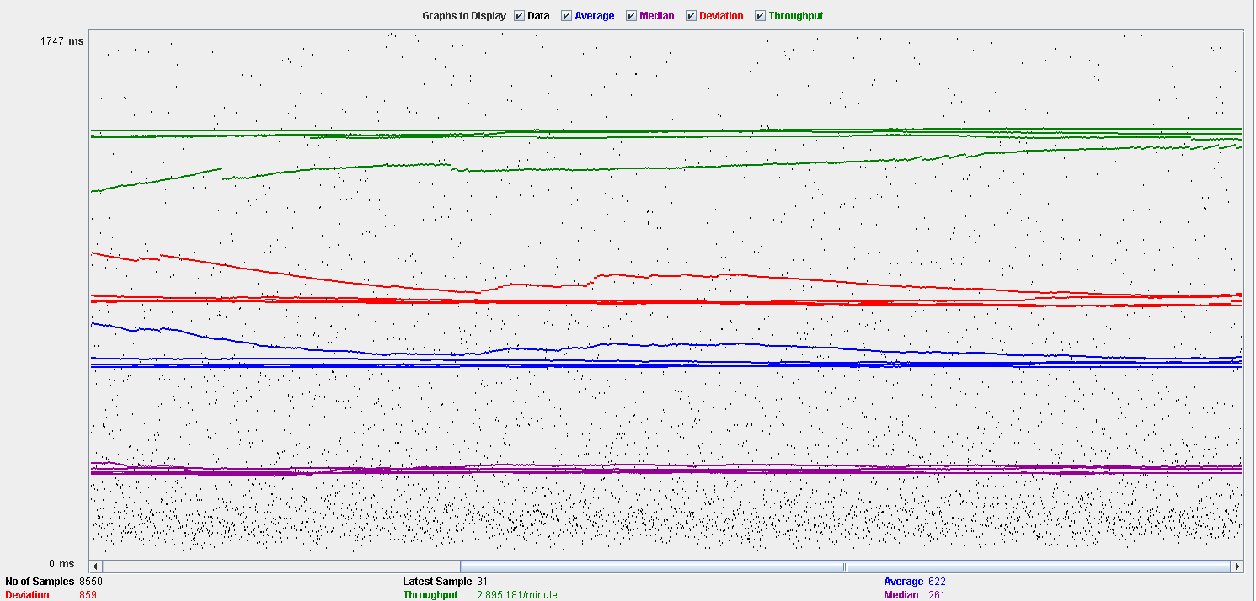

Performance Results:

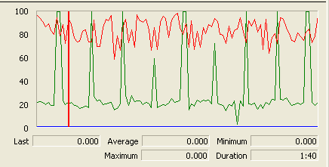

Again we can see that the CPU is always being used while the disk usage shows some periodic peaks.

## Delete

Sequence:

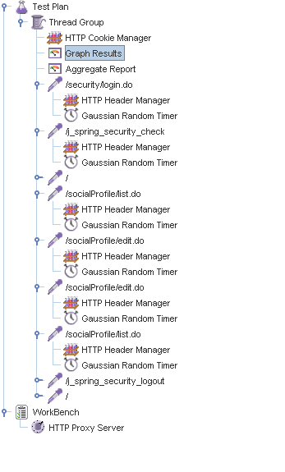

Aggregate Report:

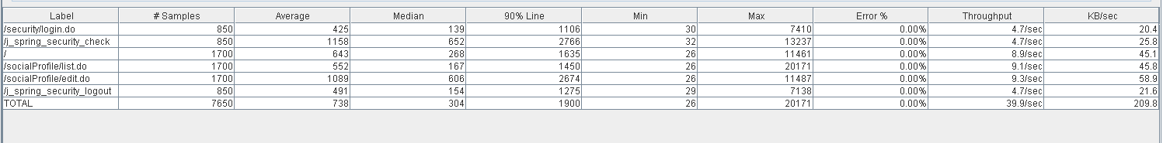

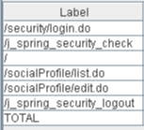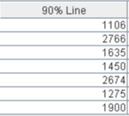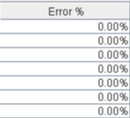

Thread properties:

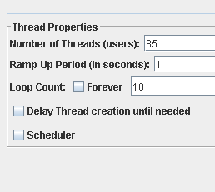.

Graph Results:

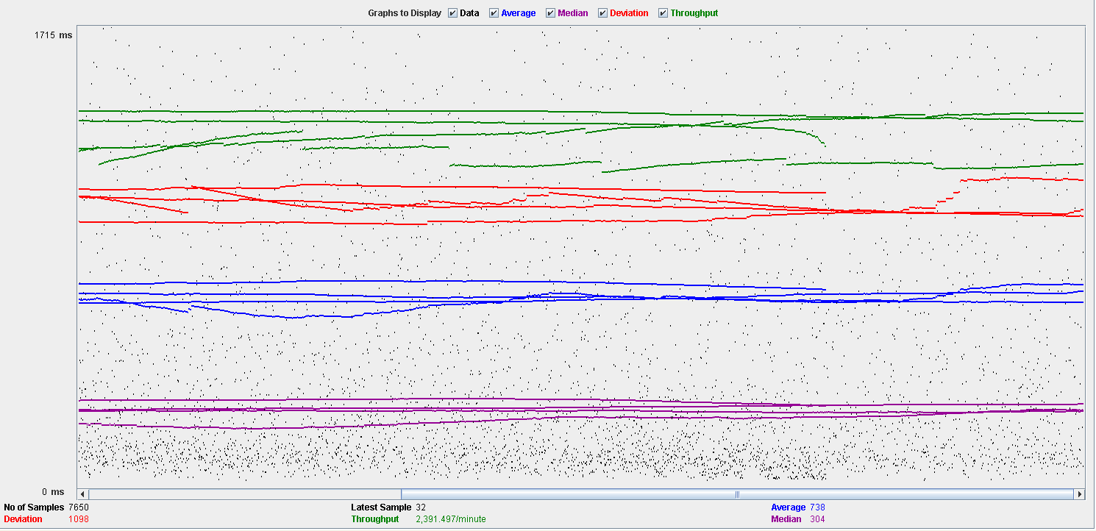

Performance Results:

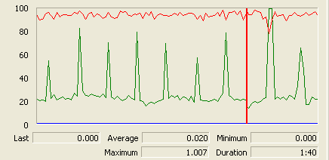

Again we can see that the CPU is always being used while the disk usage shows some peaks.

## Conclusion

The test was performed using:

CPU: i5 2500k (2 cores in the virtual machine)

RAM: 2 GB (virtual machine)

For this use case we can say that the limitation occurs during the creation process, being the maximum of concurrent users 60.

# Dashboard

## Show dashboard and launch all process

Sequence:

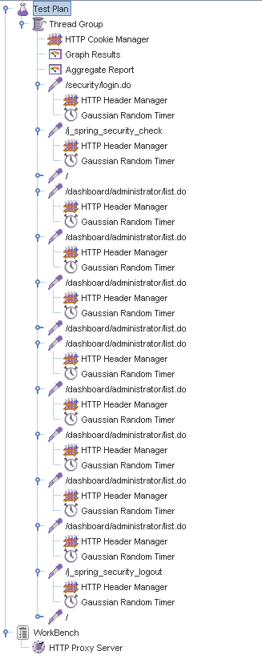

Aggregate Report:

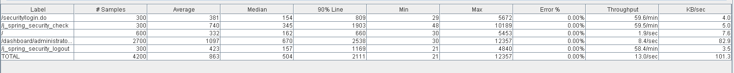

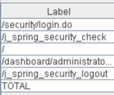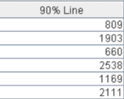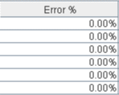

Thread properties:

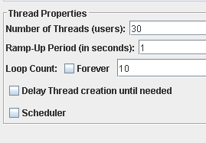

Graph Results:

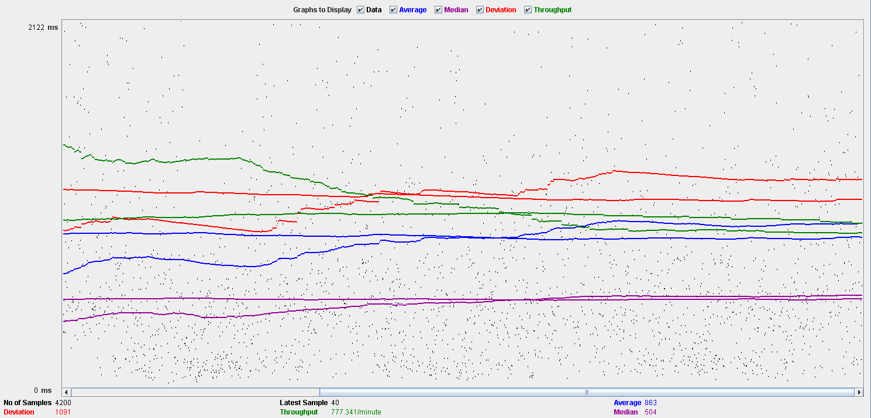

Performance Results:

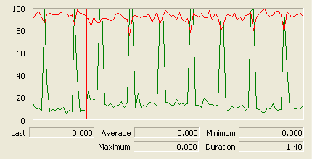

The CPU is always being used while the disk show some peaks.

## Conclusion

The test was performed using:

CPU: i5 2500k (2 cores in the virtual machine)

RAM: 2 GB (virtual machine)

For this use case we can say that the limitation around 30 users.

# Category

## Create

Sequence:

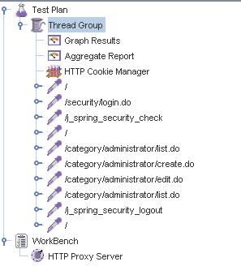

Aggregate Report:

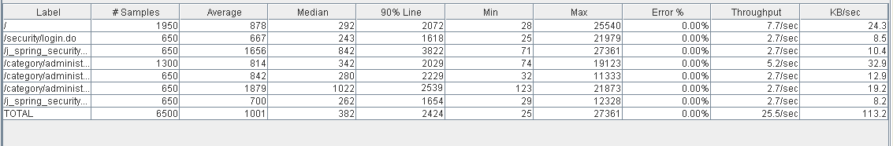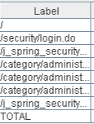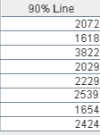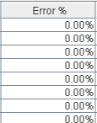

Thread properties:

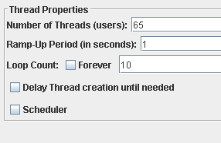

Graph Results:

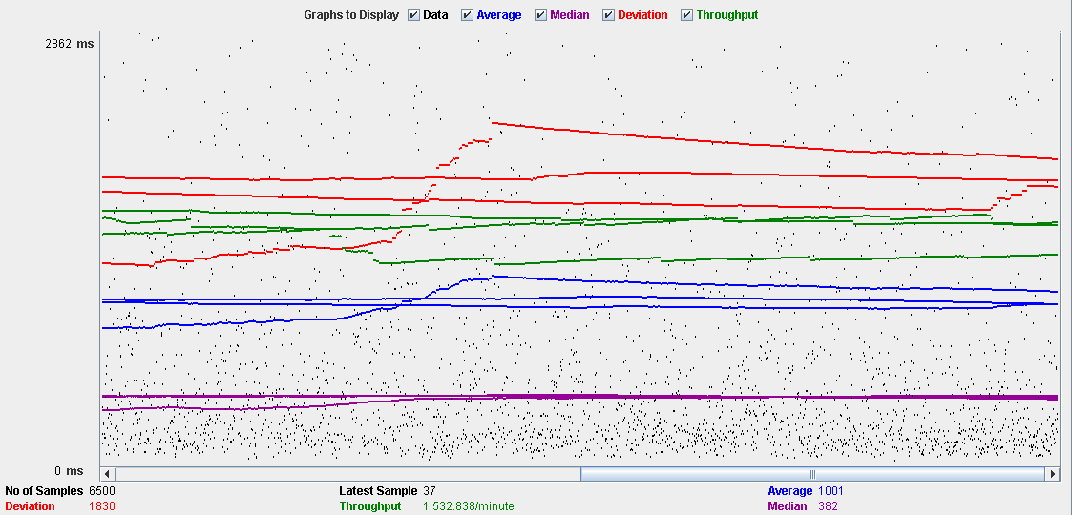

Performance Results:

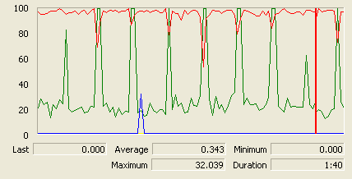

The CPU is always being used and disk show some peaks.

## Edit

Sequence:

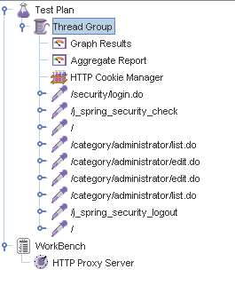

Aggregate Report:

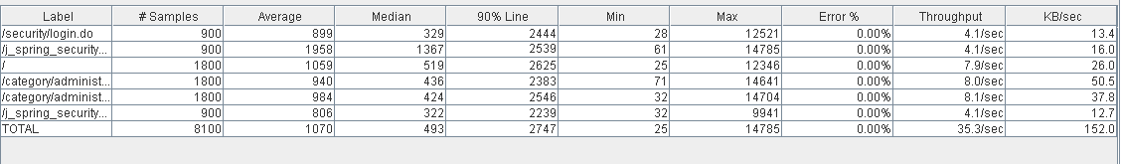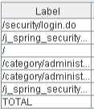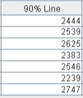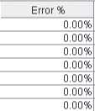

Thread properties:

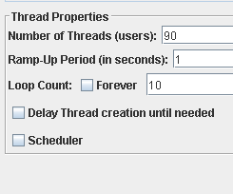

Graph Results:

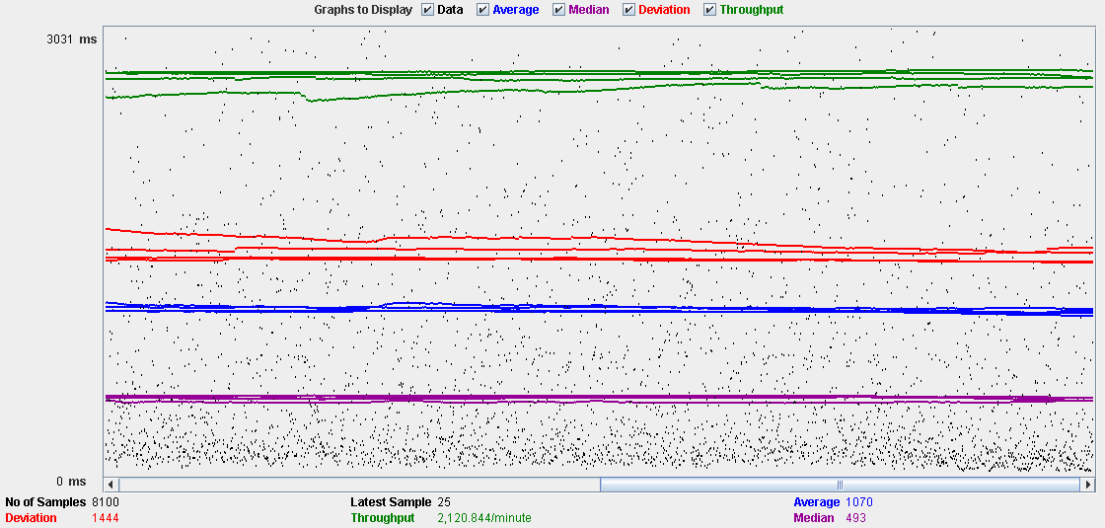

Performance Results:

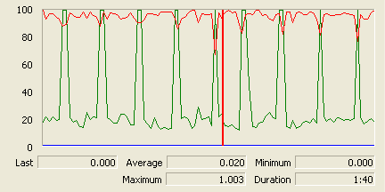

The CPU is always being used and the disk show som peaks.

## Delete

Sequence:

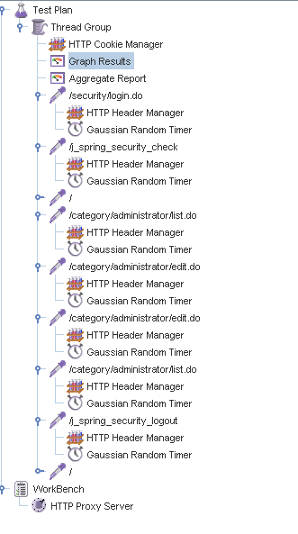

Aggregate Report:

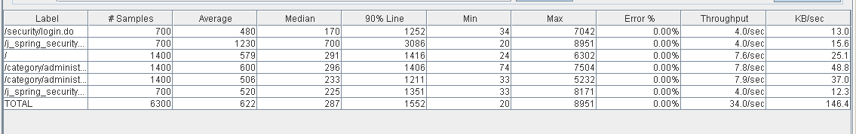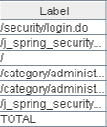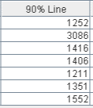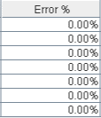

Thread properties:

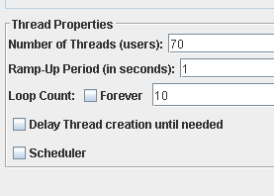

Graph Results:

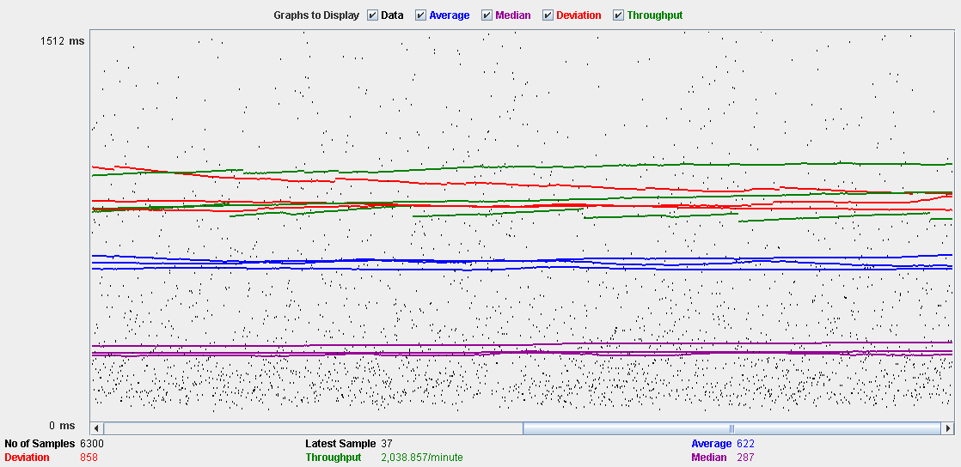

Performance Results:

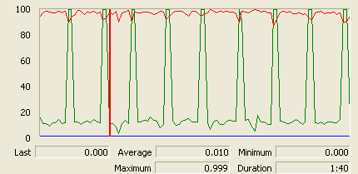

The CPU is always being used and disk show some peaks.

## Conclusion

The test was performed using:

CPU: i5 2500k (2 cores in the virtual machine)

RAM: 2 GB (virtual machine)

For this use case we can say that the limitation occurs during the create process, being the maximum of concurrent users 65.

# Request

## Create

Sequence:

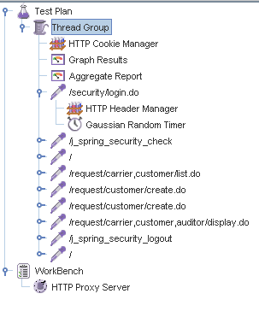

Aggregate Report:

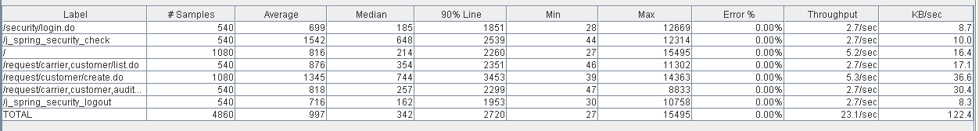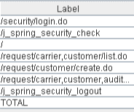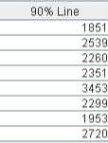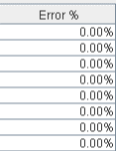

Thread properties:

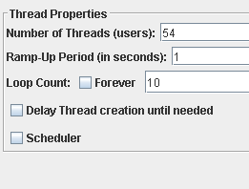

Graph Results:

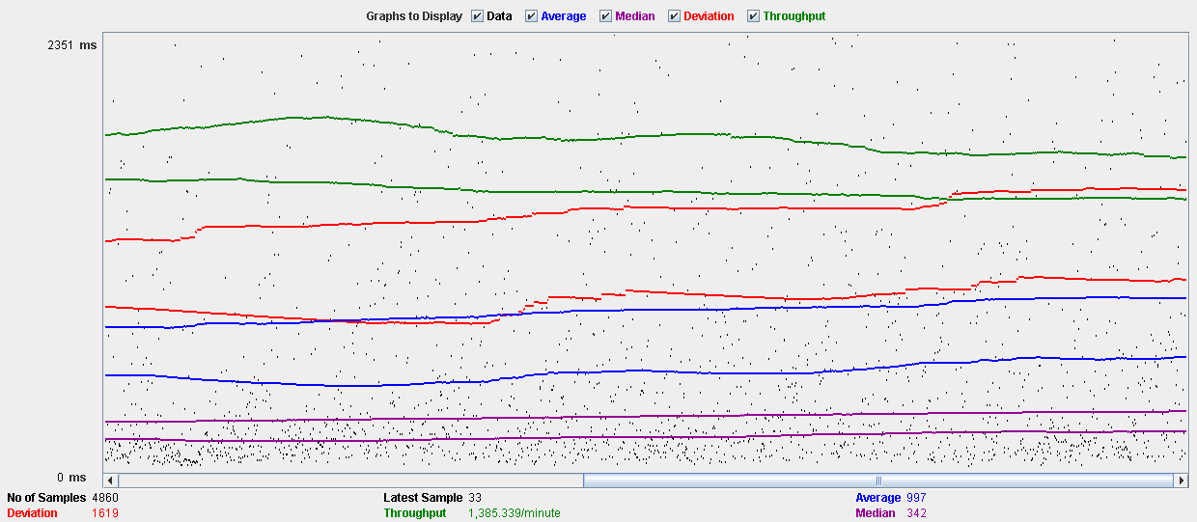

Performance Results:

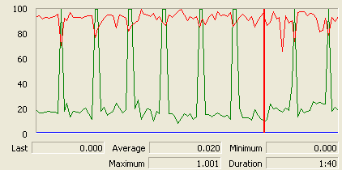

The CPU is always being used and physical disk show some peaks.

## Edit

Sequence:

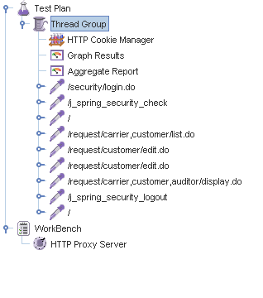

Aggregate Report:

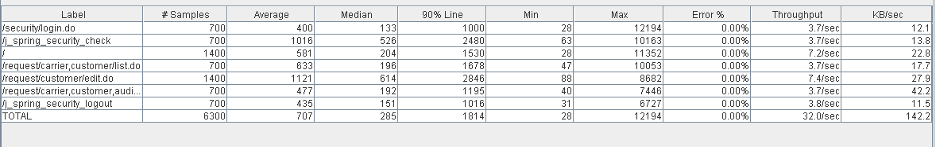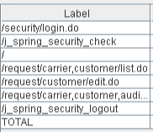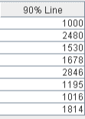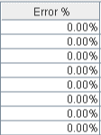

Thread properties:

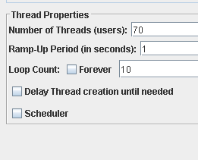

Graph Results:

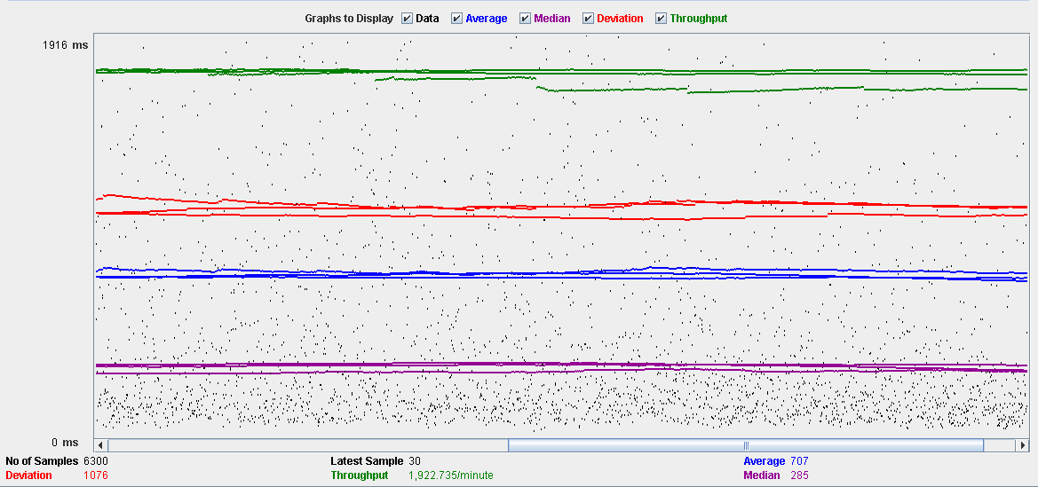

Performance Results:

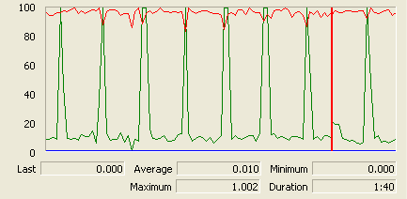

The CPU is always being used and disk show some peaks.

## Delete

Sequence:

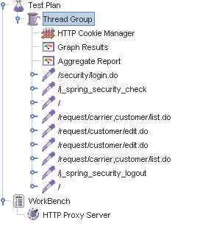

Aggregate Report:

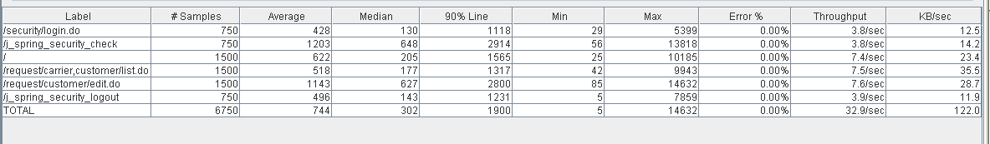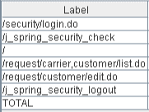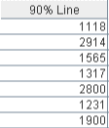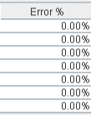

Thread properties:

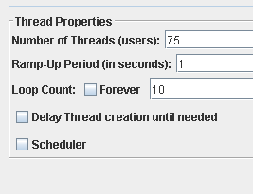

Graph Results:

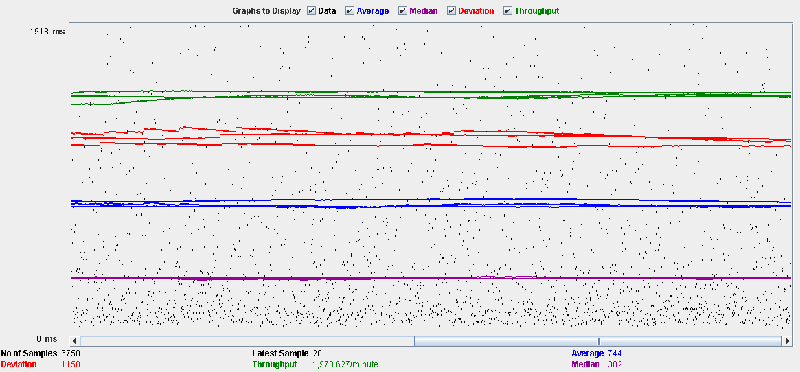

Performance Results:

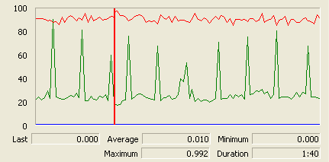

The CPU is always being used while the memory has some peaks.

## Conclusion

The test was performed using:

CPU: i5 2500kk (2 cores in the virtual machine)

RAM: 2 GB (virtual machine)

For this use case we can say that the limitation occurs during the creation process, being the maximum of concurrent users 54.

# TraverseTown

## Create

Sequence:

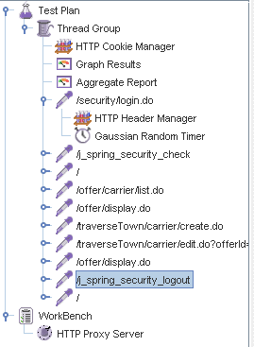

Aggregate Report:

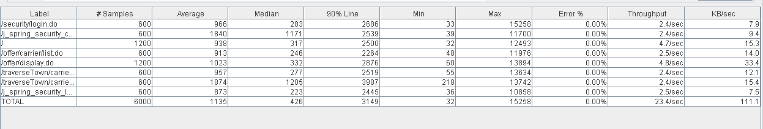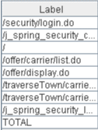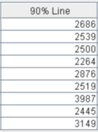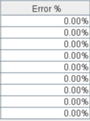

Thread properties:

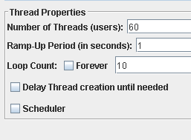

Graph Results:

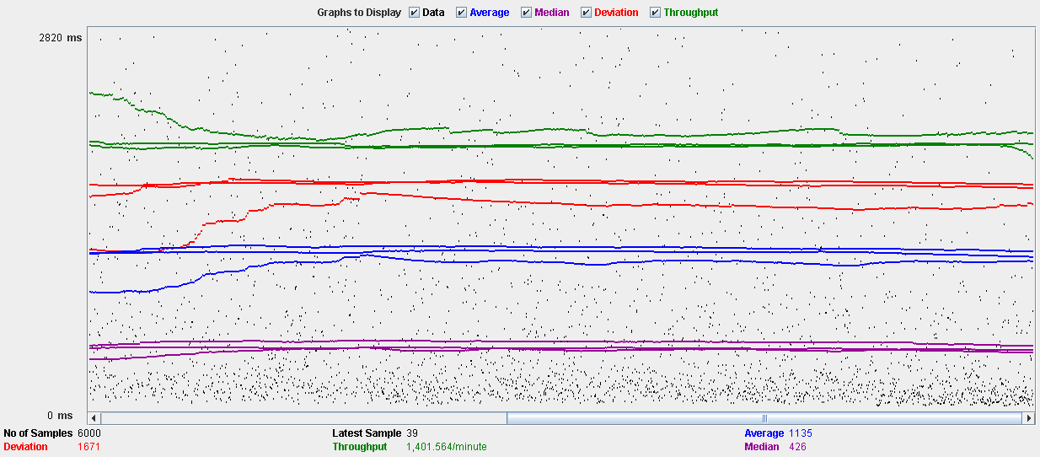

Performance Results:

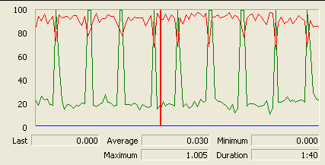

The CPU is always being used and physical disk show some peaks.

## Edit

Sequence:

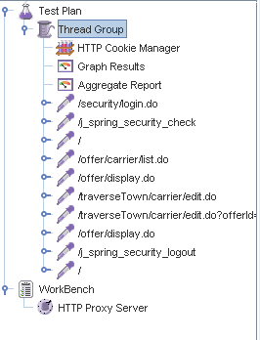

Aggregate Report:

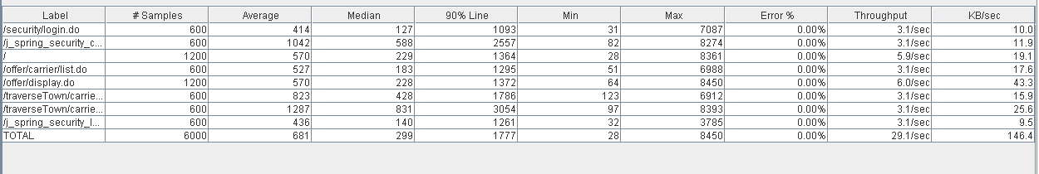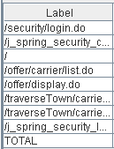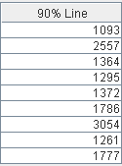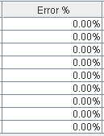

Thread properties:

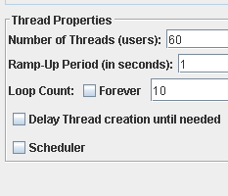

Graph Results:

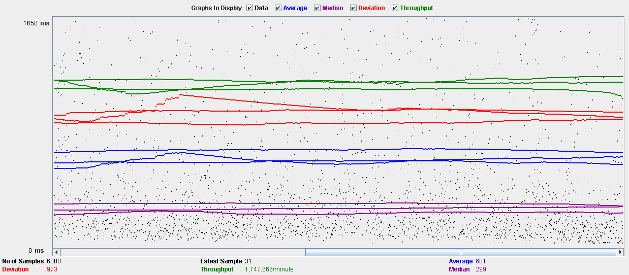

Performance Results:

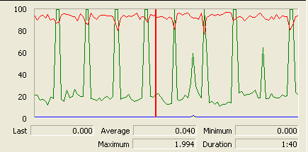

The CPU is always being used and disk show some peaks

## Delete

Sequence:

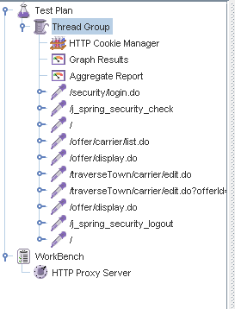

Aggregate Report:

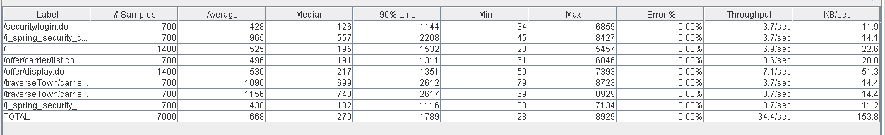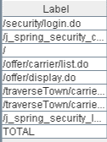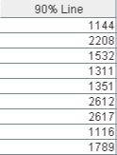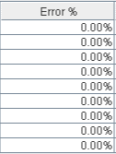

Thread properties:

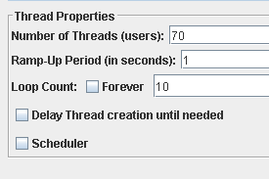

Graph Results:

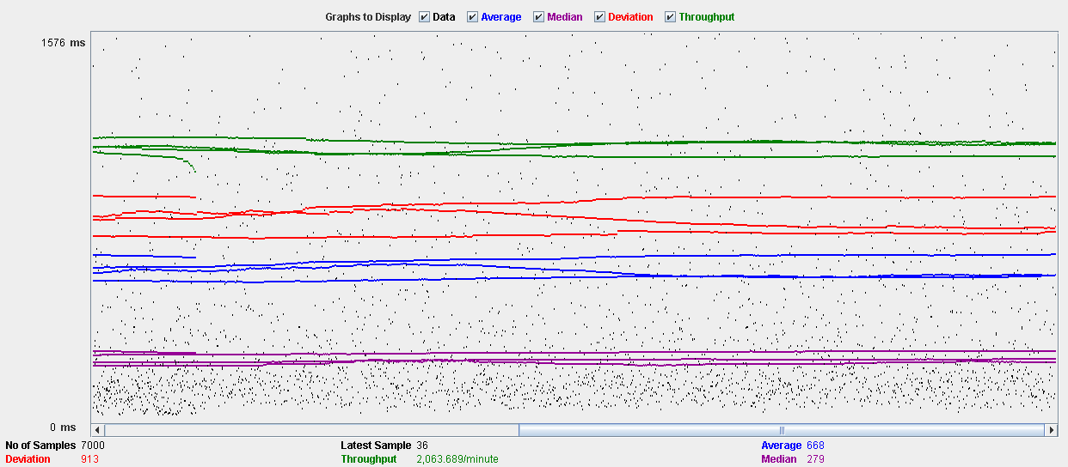

Performance Results:

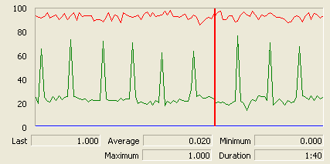

The CPU is always being used while the memory has some peaks.

## Conclusion

The test was performed using:

CPU: i5 2500k (2 cores in the virtual machine)

RAM: 2 GB (virtual machine)

For this use case we can say that the limitation occurs during the creation and edition process, being the maximum of concurrent users 60.

# Issue

## Create

Sequence:

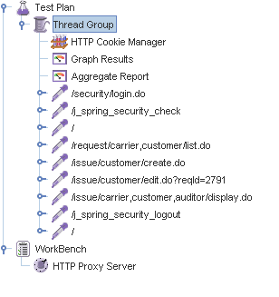

Aggregate Report:

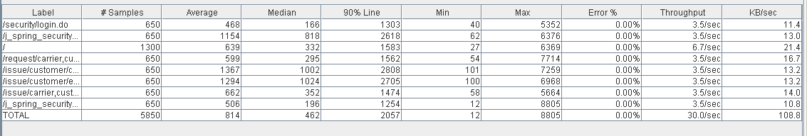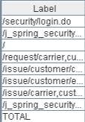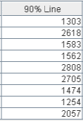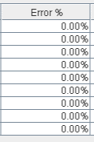

Thread properties:

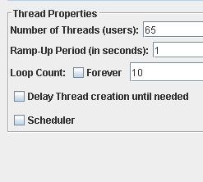

Graph Results:

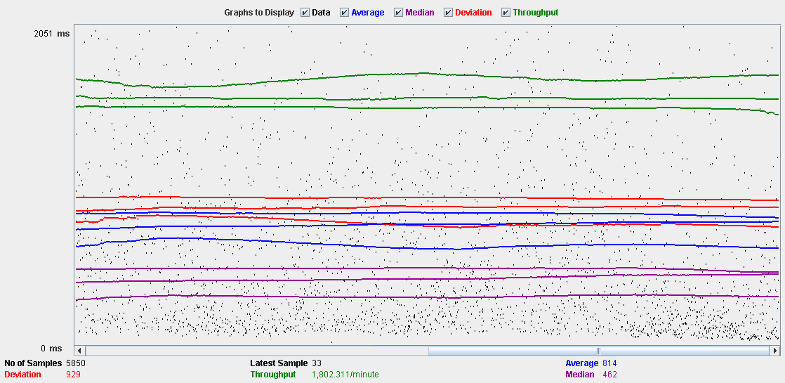

Performance Results:

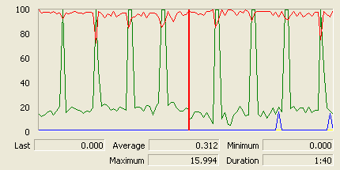

The CPU is always being used and physical disk usage show some peaks.

## Delete

Sequence:

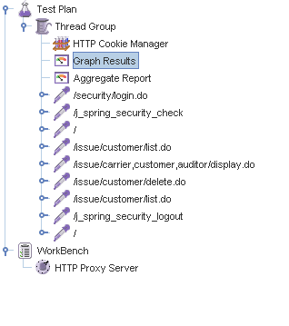

Aggregate Report:

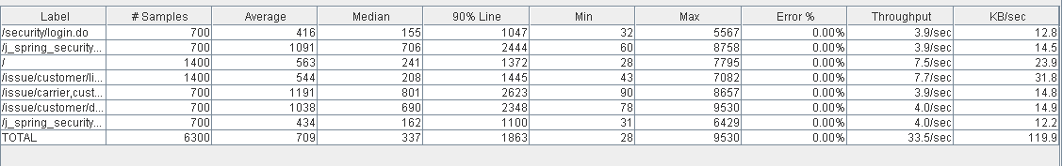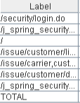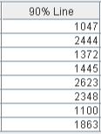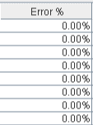

Thread properties:

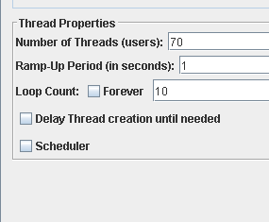

Graph Results:

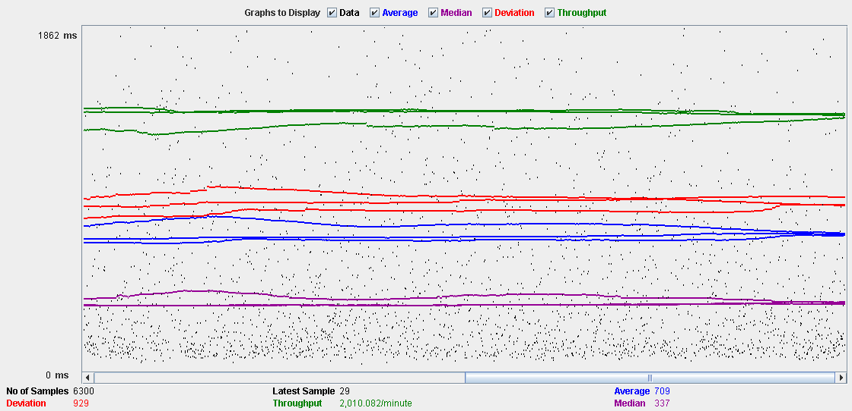

Performance Results:

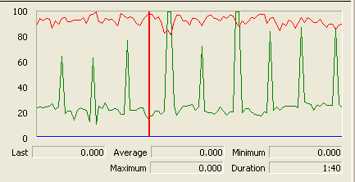

The CPU is always being used and disk show some peaks-

## Conclusion

The test was performed using:

CPU: i5 2500k (2 cores in the virtual machine)

RAM: 2 GB (virtual machine)

For this use case we can say that the limitation occurs during the create process, being the maximum of concurrent users 65.

# Town

## Create

Sequence:

Aggregate Report:

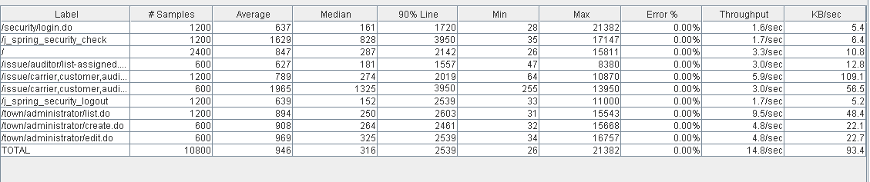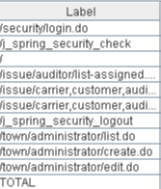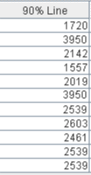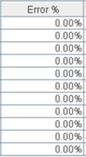

Thread properties:

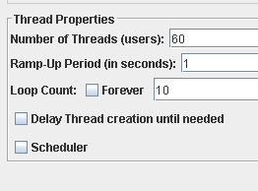

Graph Results:

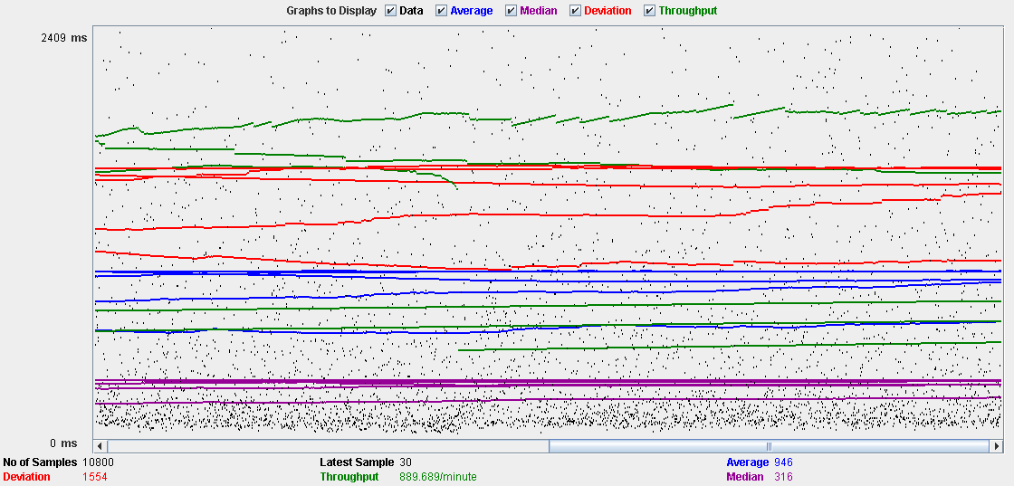

Performance Results:

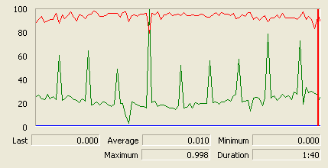

The CPU is always being used and physical disk usage show some peaks.

## Edit

Sequence:

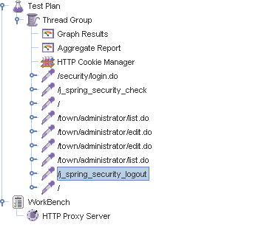

Aggregate Report:

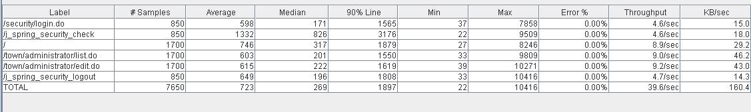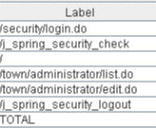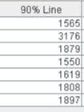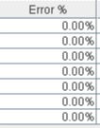

Thread properties:

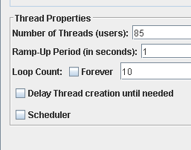

Graph Results:

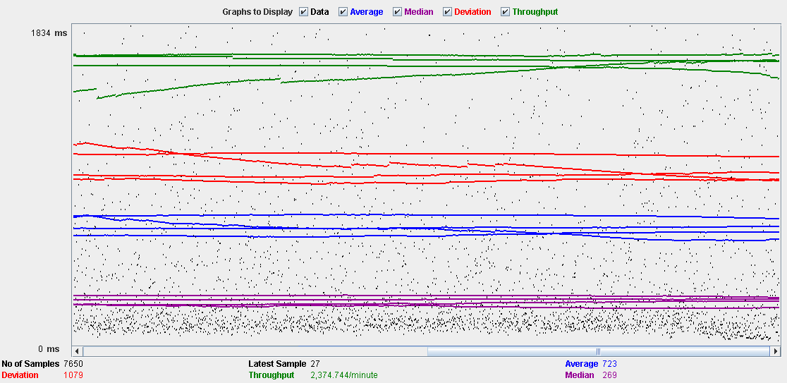

Performance Results:

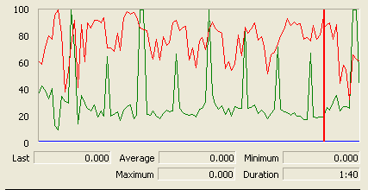

The CPU is always being used and small picks of physical disk

## Delete

Sequence:

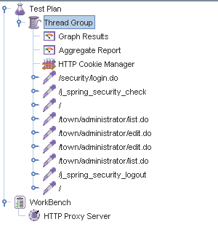

Aggregate Report:

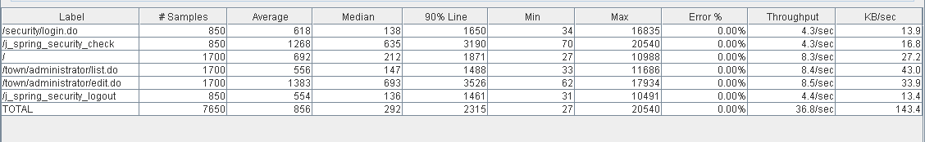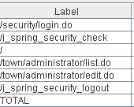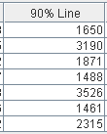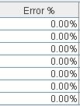

Thread properties:

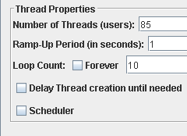

Graph Results:

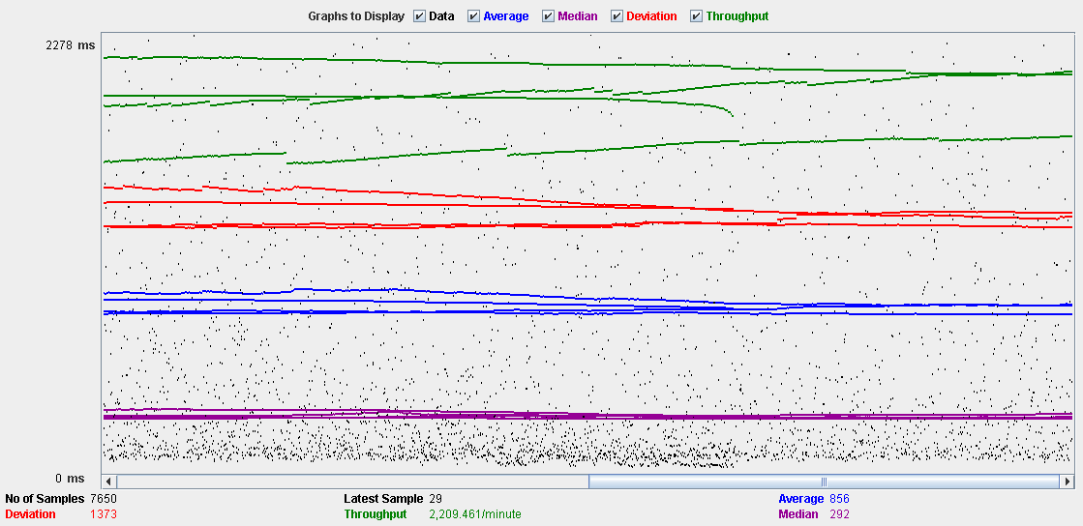

Performance Results:

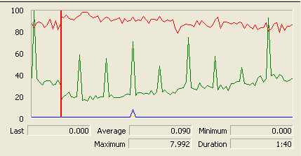

The CPU is always being used while the memory has some peaks.

## Conclusion

The test was performed using:

CPU: i5 2500k (2 cores in the virtual machine)

RAM: 2 GB (virtual machine)

For this use case we can say that the limitation occurs during the create process, being the maximum of concurrent users 60.

# Comment

## Create

Sequence:

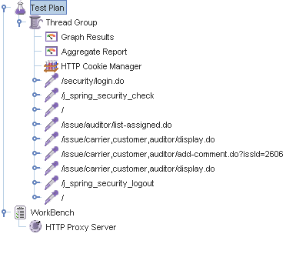

Aggregate Report:

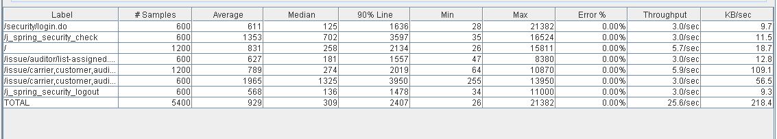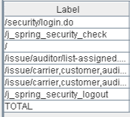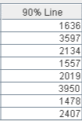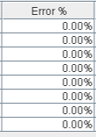

Thread properties:

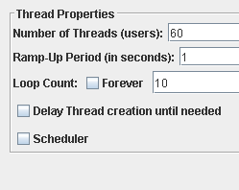

Graph Results:

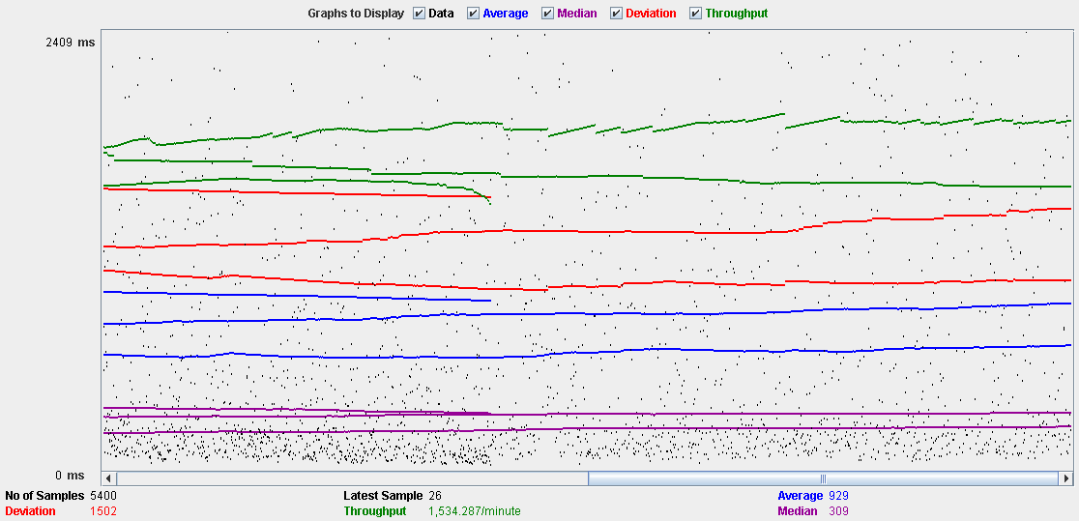

Performance Results:

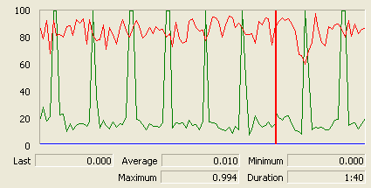

The CPU is always being used and physical disk usage is barely noticeable.

## Conclusion

The test was performed using:

CPU: i5 2500k (2 cores in the virtual machine)

RAM: 2 GB (virtual machine)

For this use case we can say that the limitation occurs with 60 users.

# Configuration

## Display and edit

Sequence:

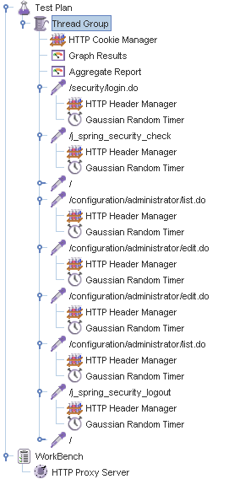

Aggregate Report:

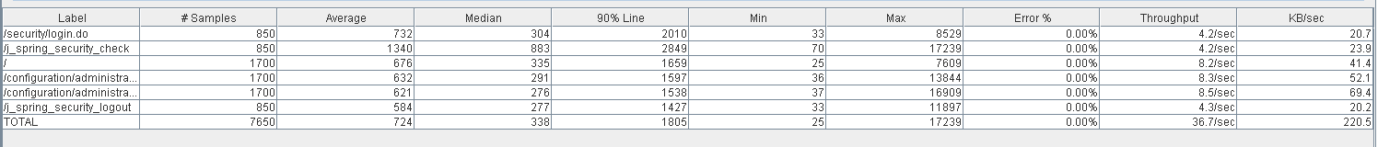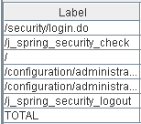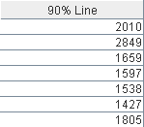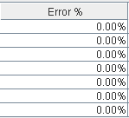

Thread properties:

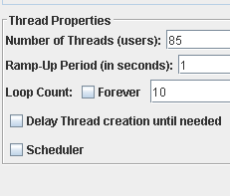

Graph Results:

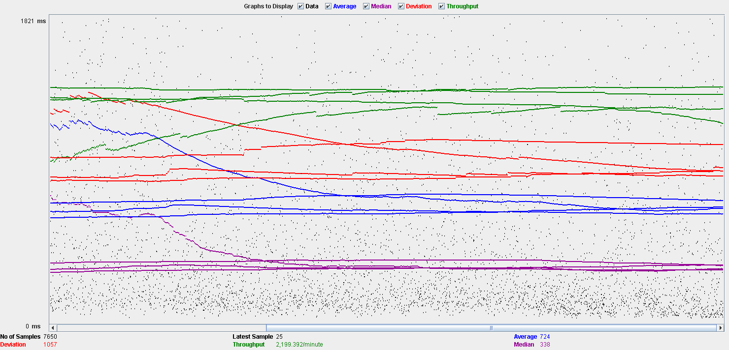

Performance Results:

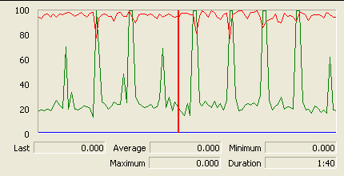

The CPU is always being used and physical disk usage show some peaks.

## Conclusion

The test was performed using:

CPU: i5 2500k (2 cores in the virtual machine)

RAM: 2 GB (virtual machine)

For this use case we can say that the limitation occurs during the edition process, being the maximum of concurrent users 85.

# Finder

## Search

Sequence:

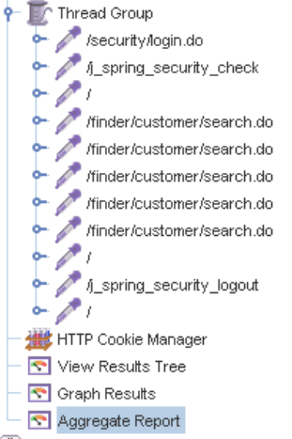

Aggregate Report:

 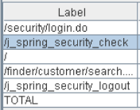 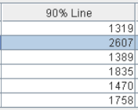 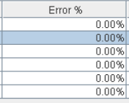

Thread properties:

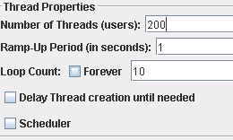

Graph Results:

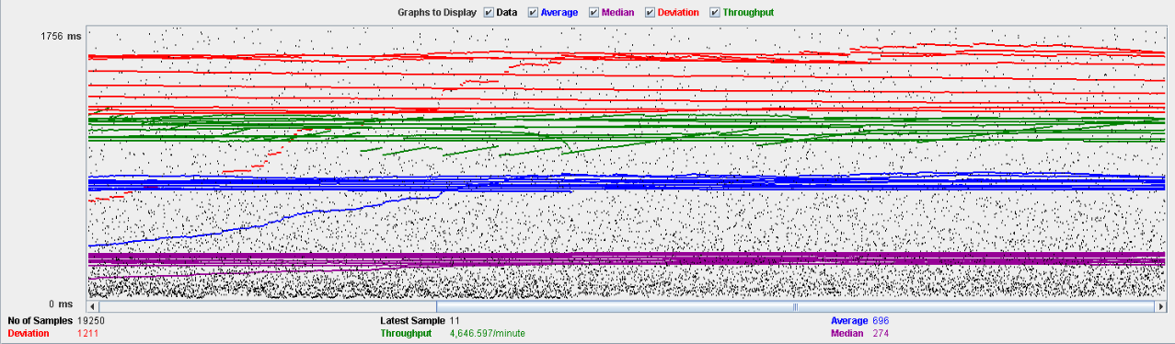

Performance Results:

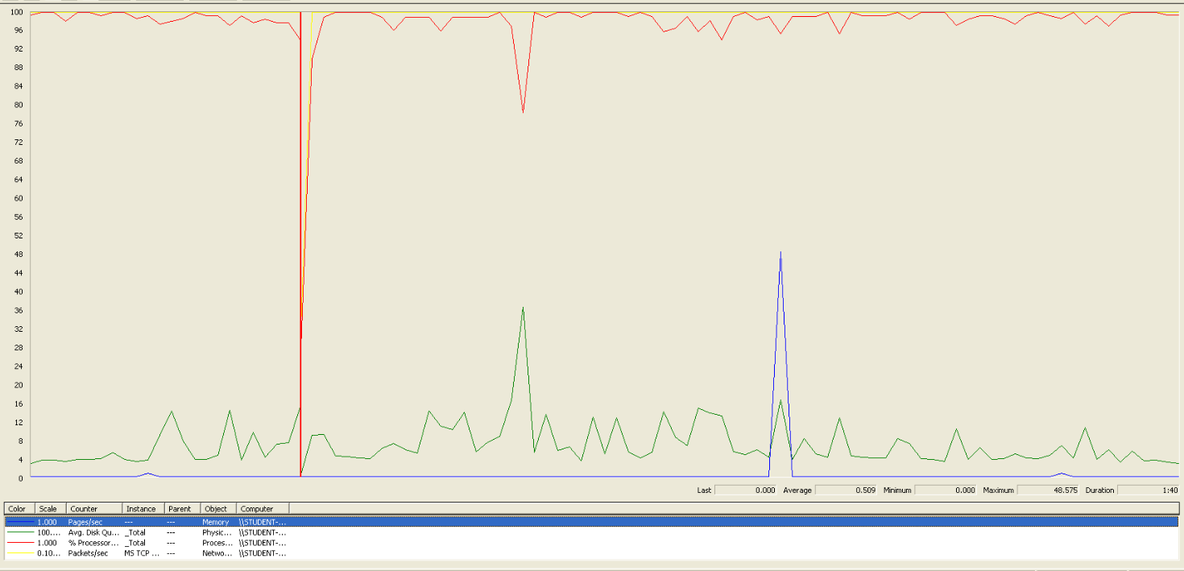

We can clearly see that the bottleneck is the CPU.

## Conclusion

The test was performed using:

CPU: i5 7300HQ (2 cores in the virtual machine)

RAM: 2 GB (virtual machine)

For this use case we can say that the maximum of concurrent users is about 200.

# Offer

## Create/Edit

Sequence:

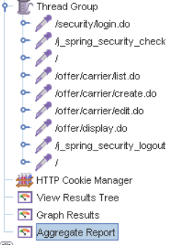

Aggregate Report:

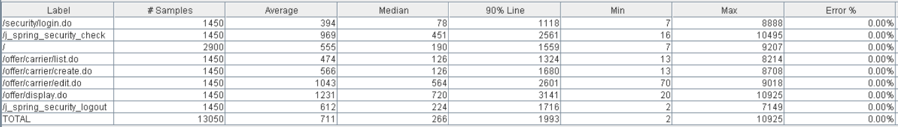 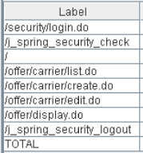 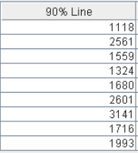 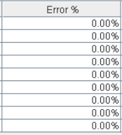

Thread properties:

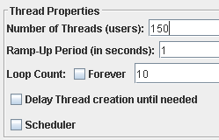

Graph Results:

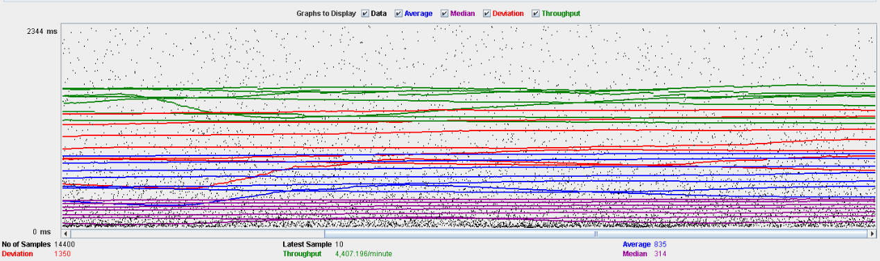

Performance Results:

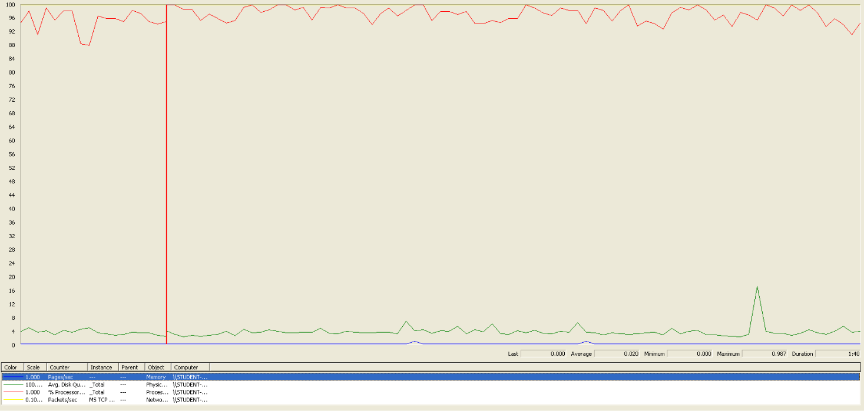

We can clearly see that the bottleneck is the CPU.

## Delete

Sequence:

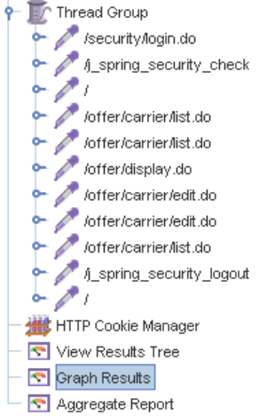

Aggregate Report:

 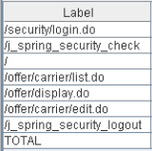 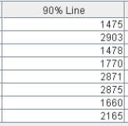 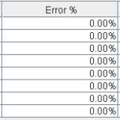

Thread properties:

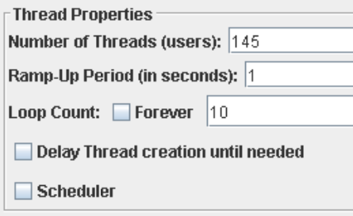

Graph Results:

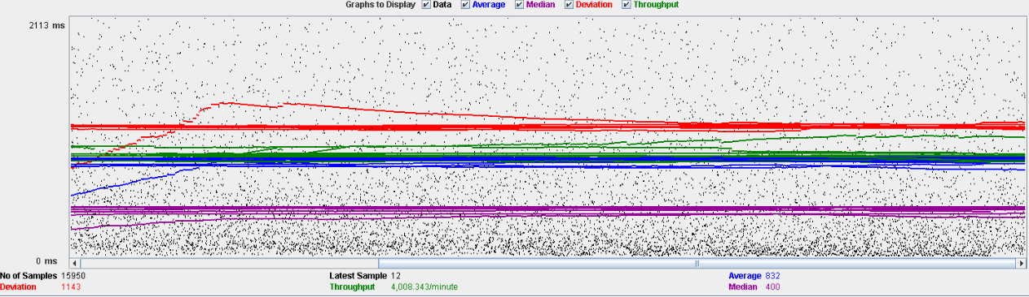

Performance Results:

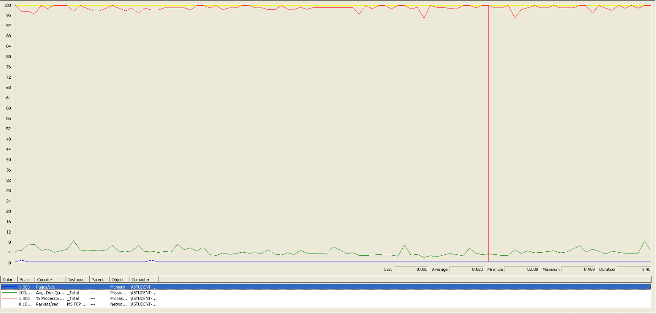

We can clearly see, another time, that the bottleneck is the CPU.

## Conclusion

The test was performed using:

CPU: i5 7300HQ (2 cores in the virtual machine)

RAM: 2 GB (virtual machine)

For this use case we can say that the maximum of concurrent users is about 145, delimited by the delete.

# Curricula

## Create a curriculum

Sequence:

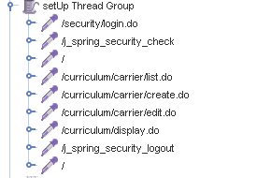

Aggregate Report:

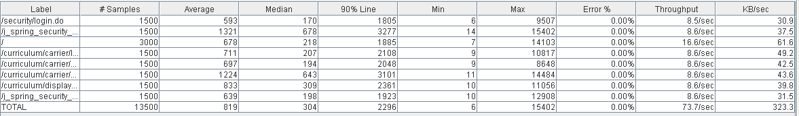

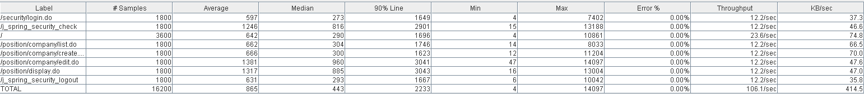

Thread properties:

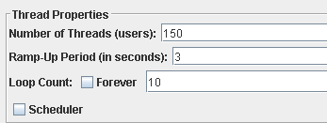

Graph Results:

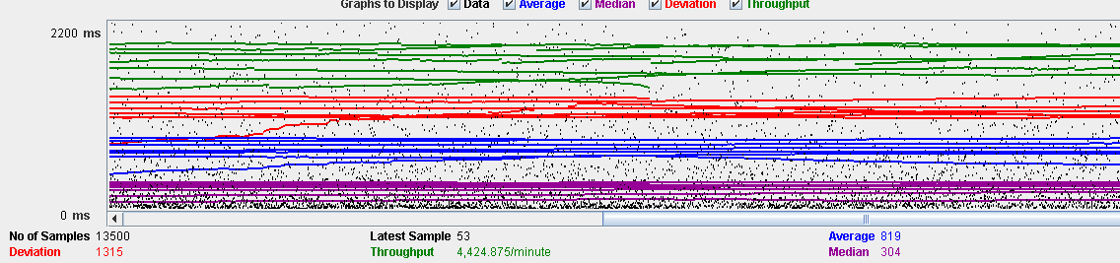

Performance Results:

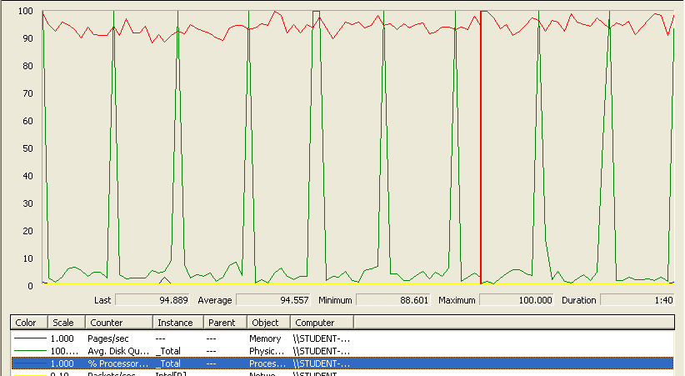

The CPU was always at its limit while the disk usage showed many peaks.

## Edit a curriculum

Sequence:

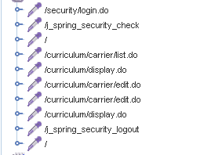

Aggregate Report:

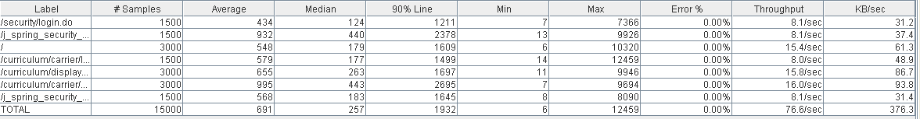



Thread properties:



Graph Results:

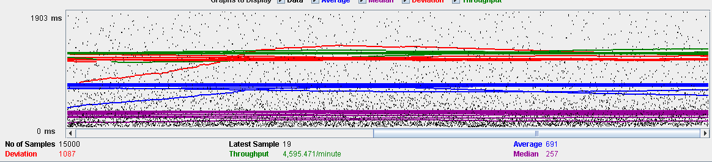

Performance Results:

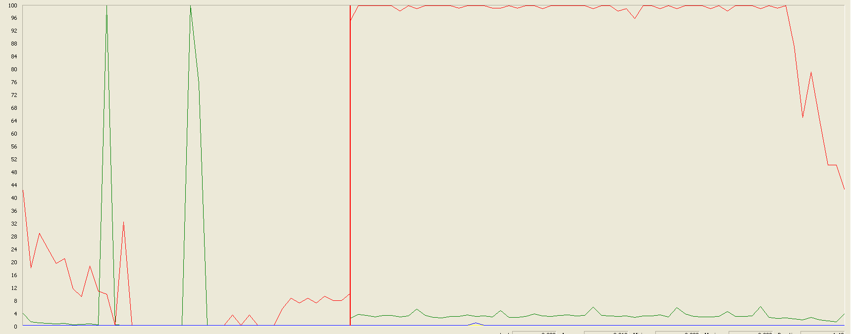

The CPU was always at its limit while the disk usage showed many peaks.

## Delete a curriculum

Sequence:

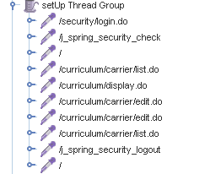

Aggregate Report:

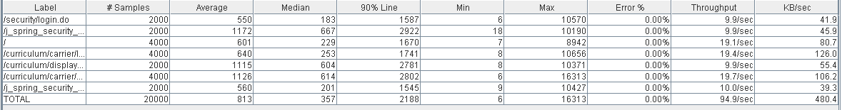



Thread properties:

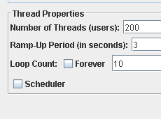

Graph Results:

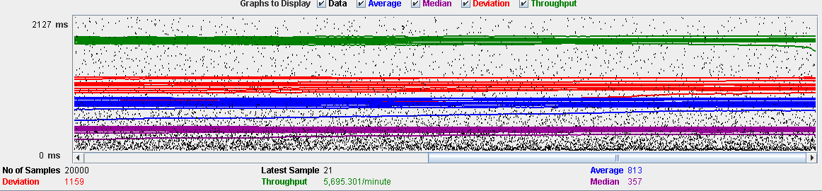

Performance Results:

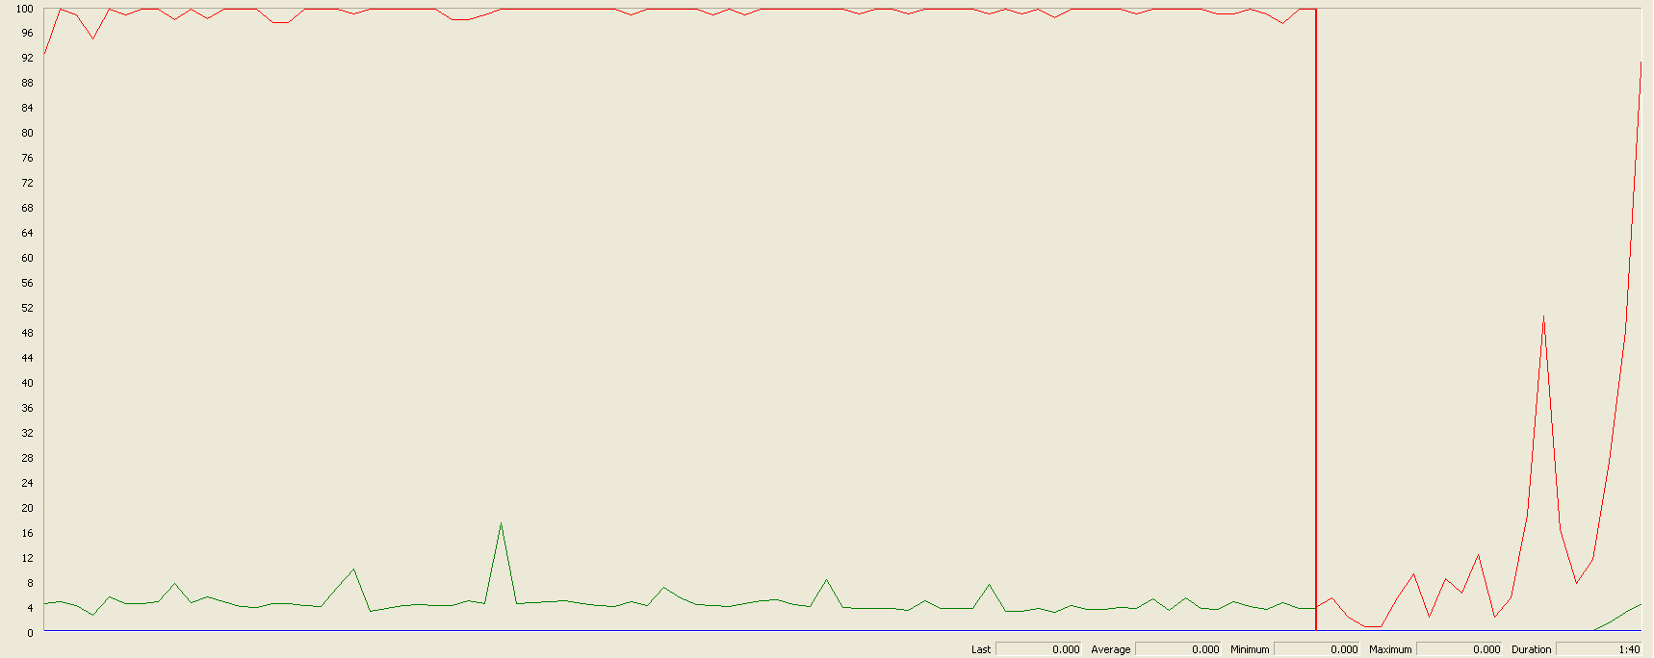

Again we can see that the CPU is always being used while the disk usage shows some little peaks.

## Conclusion

The test was performed using:

CPU: i7 7700hq (2 cores in the virtual machine)

RAM: 2 GB (virtual machine)

For this use case we can say that the limitation occurs during the creation and edition process, being the maximum of concurrent users 150.

# Records (Professional and Miscellaneous record)

## Create Miscellaneous Record

Sequence:

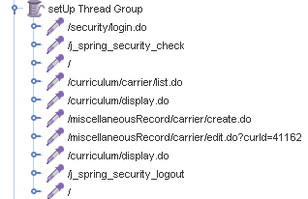

Aggregate Report:

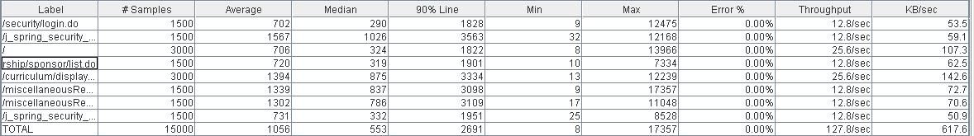



Thread properties:

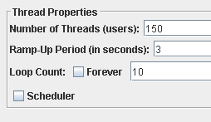

Graph Results:

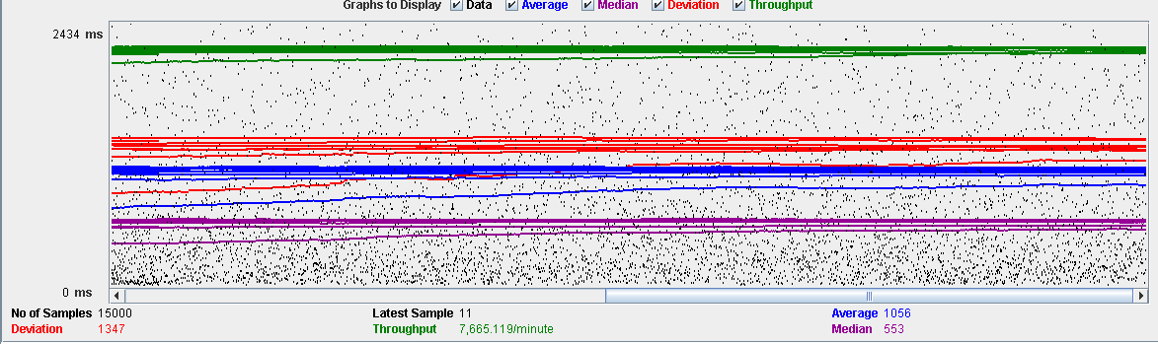

Performance Results:

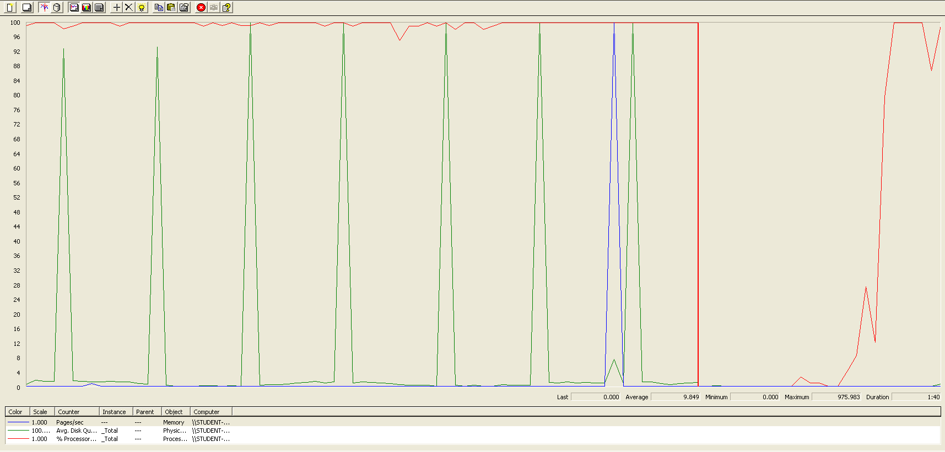

Again we can see that the CPU is always being used while the disk usage shows some periodic peaks.

## Create Professional Record

Sequence:

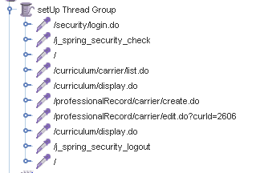

Aggregate Report:

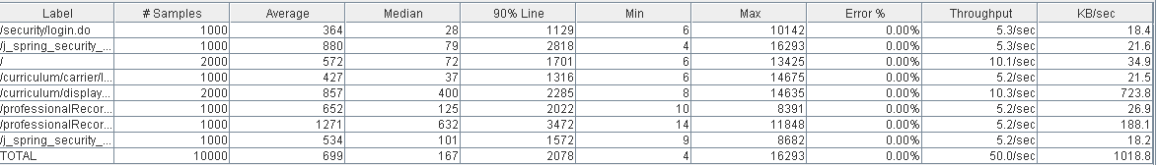



Thread properties:

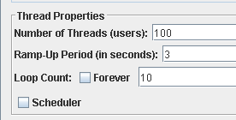

Graph Results:

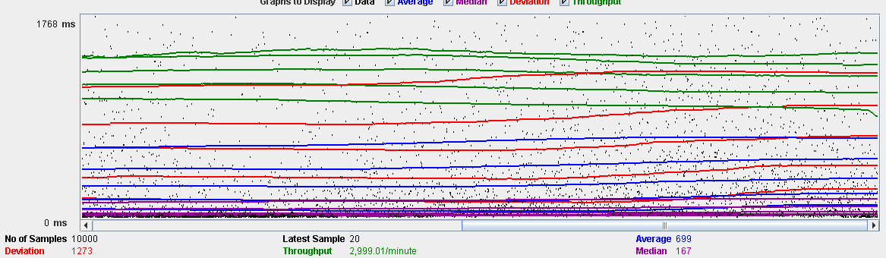

Performance Results:

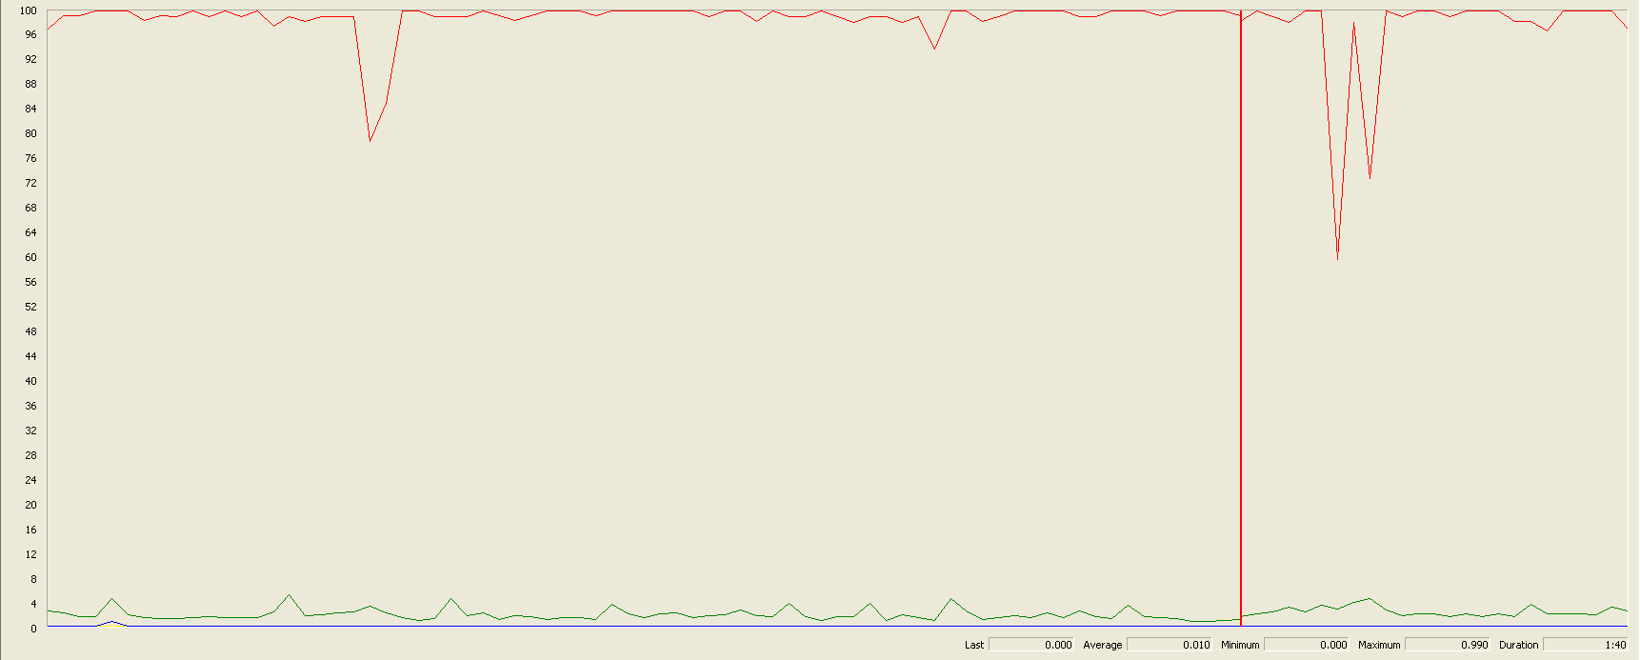

Again we can see that the CPU is always being used while the disk usage shows some low peaks

## Edit a Miscellaneous Record

Sequence:

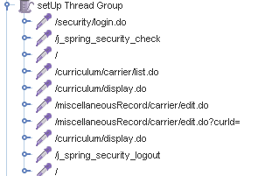

Aggregate Report:

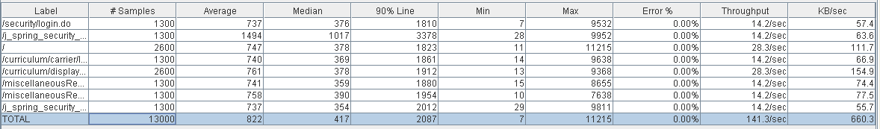



Thread properties:

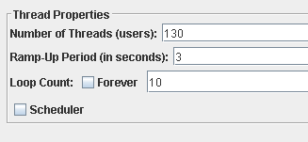

Graph Results:

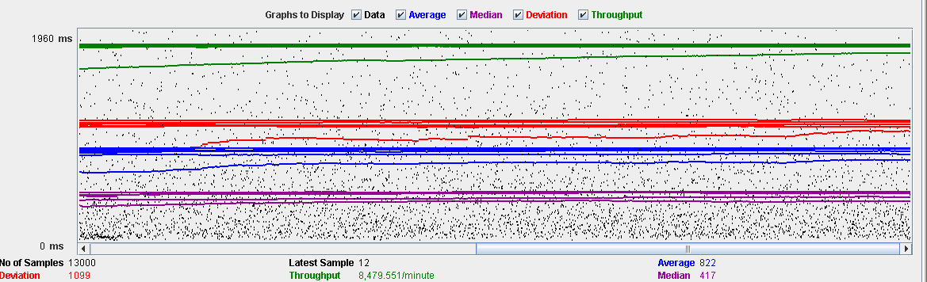

Performance Results:

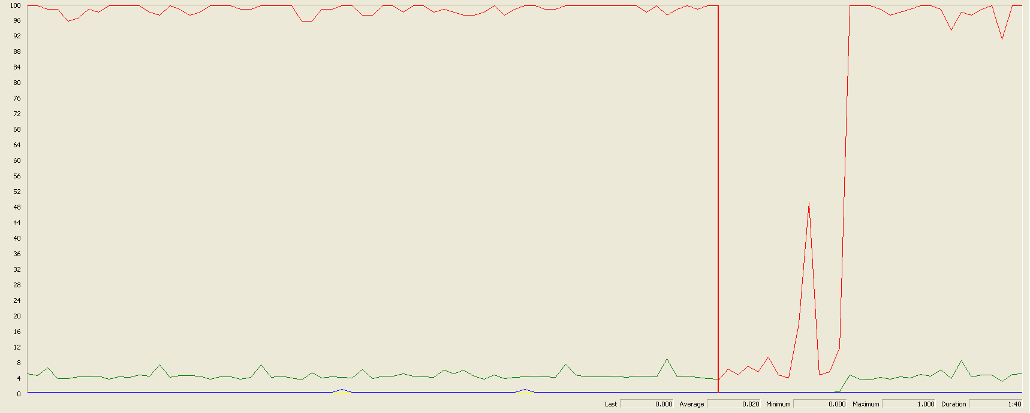

Again we can see that the CPU is always being used while the disk usage shows some peaks.

## Edit a Professional Record

Sequence:

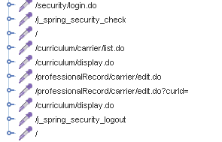

Aggregate Report:

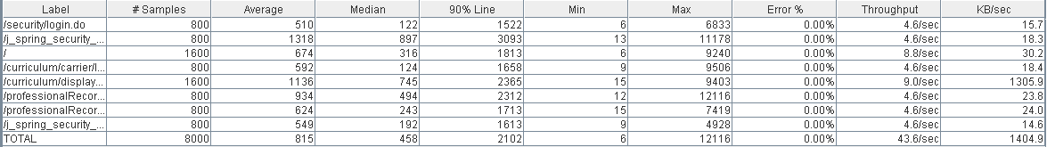



Thread properties:

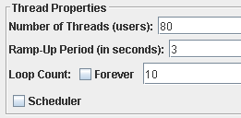

Graph Results:

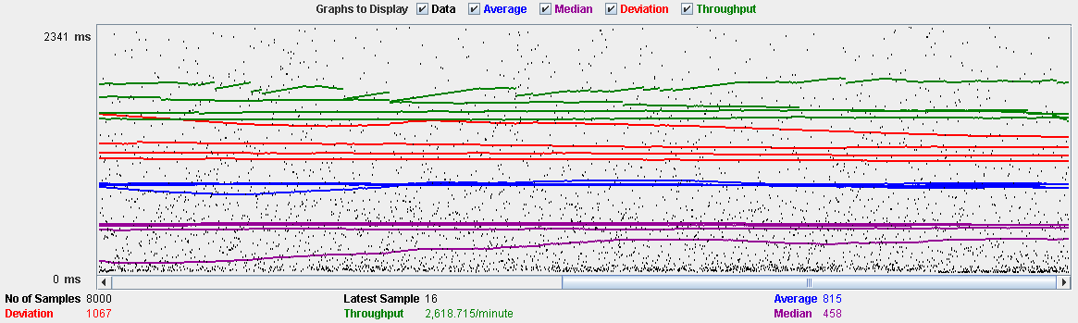

Performance Results:

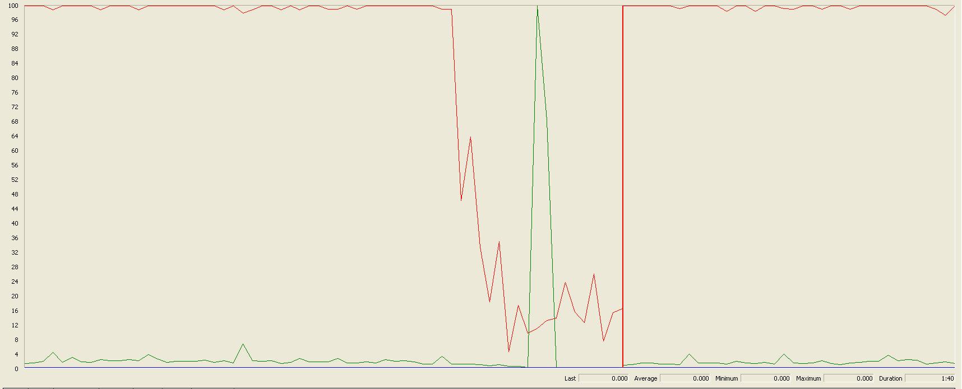

Again we can see that the CPU is always being used while the disk usage shows some peaks.

## Delete a professional record

Sequence:



Aggregate Report:

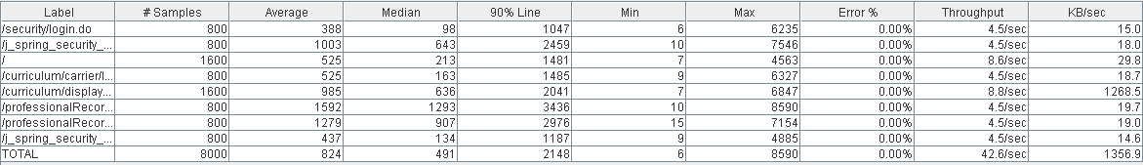

 

Thread properties:

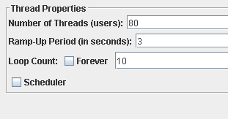

Graph Results:

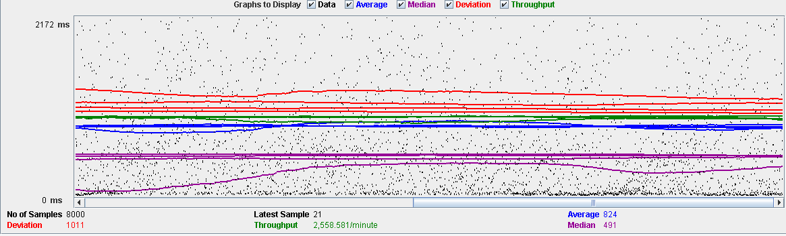

Performance Results:

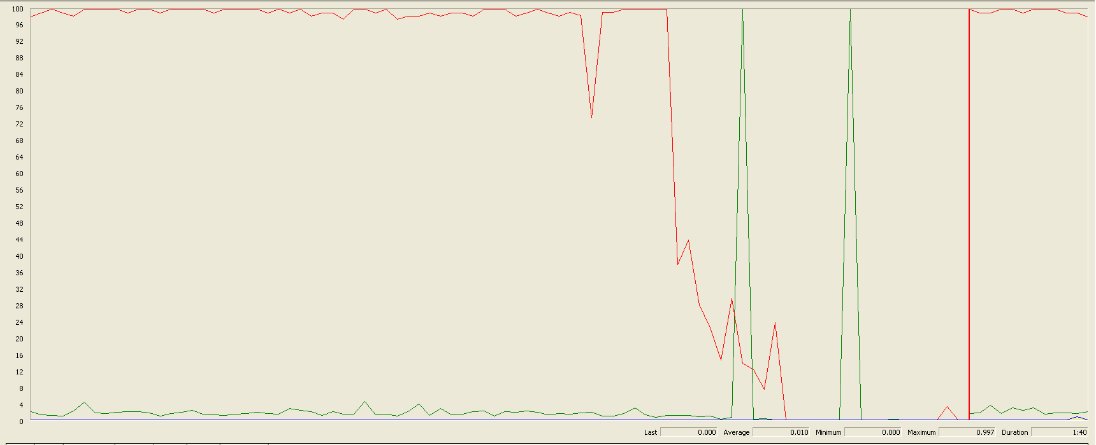

Again we can see that the CPU is always being used while the disk usage shows two peaks.

## Delete a miscellaneous data

Sequence:



Aggregate Report:

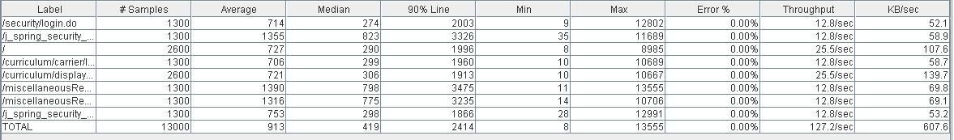

 

Thread properties:



Graph Results:

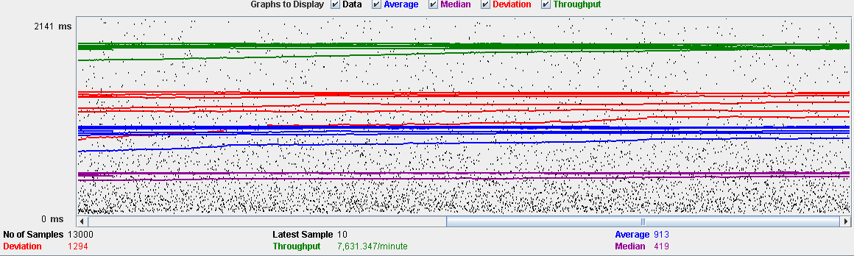

Performance Results:

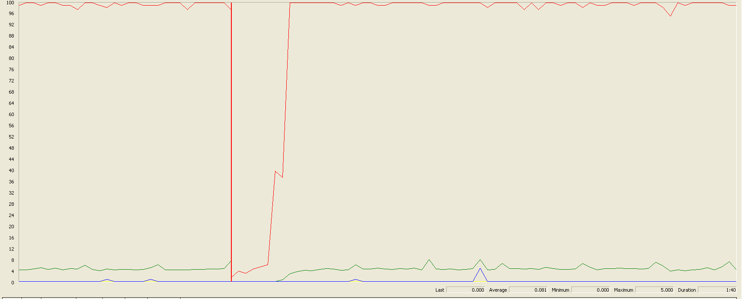

Again we can see that the CPU is always being used while the disk usage shows little peaks.

## Conclusion

The test was performed using:

CPU: i7 6700hq (2 cores in the virtual machine)

RAM: 4 GB (virtual machine)

For this use case we can say that the limitation occurs during the creation process, being the maximum of concurrent users 80.

# Actor

## Create

Sequence:

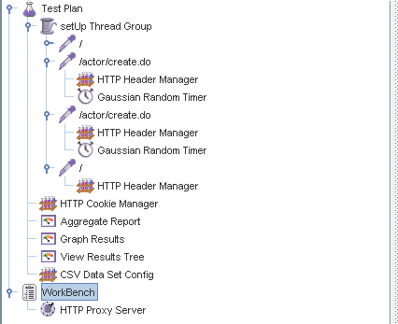

Aggregate Report:



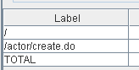  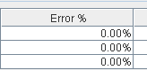

Thread properties:

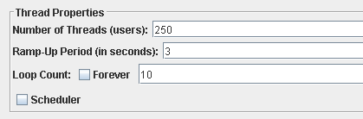

Graph Results:

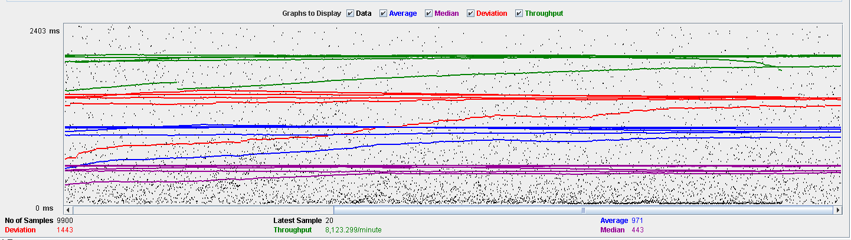

Performance Results:

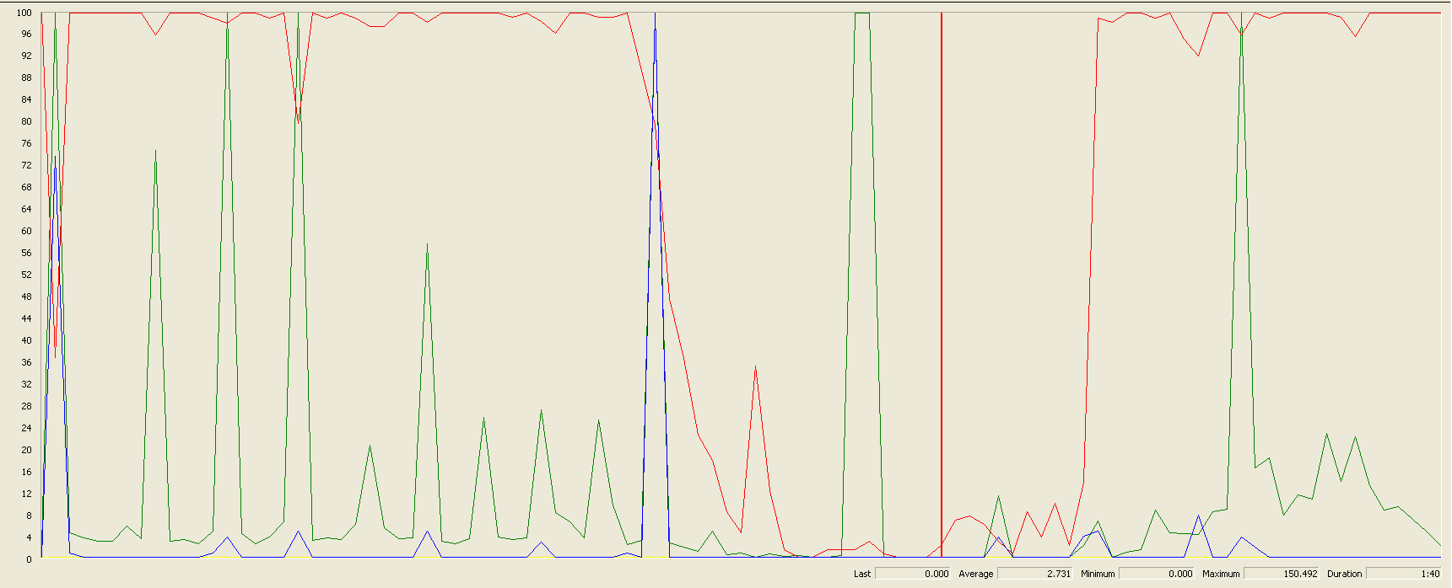

The CPU was always at its limit while the disk usage has a lot of peaks.

## Edit

Sequence:

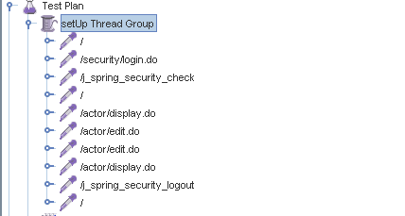

Aggregate Report:

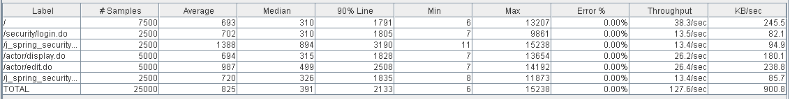



Thread properties:

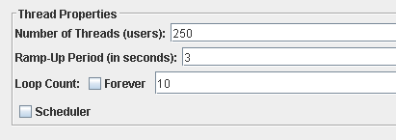

Graph Results:

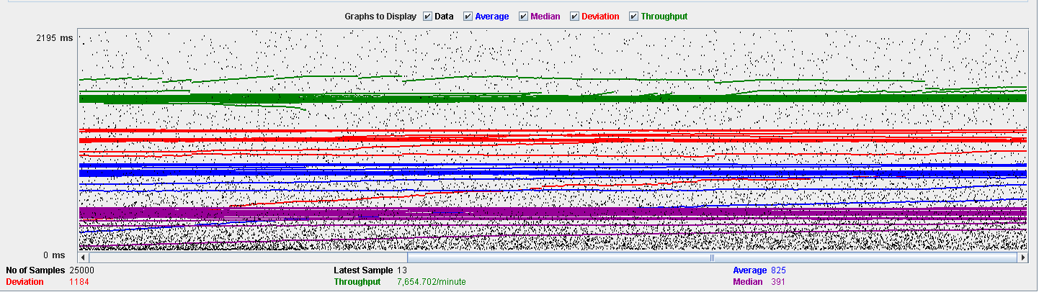

Performance Results:

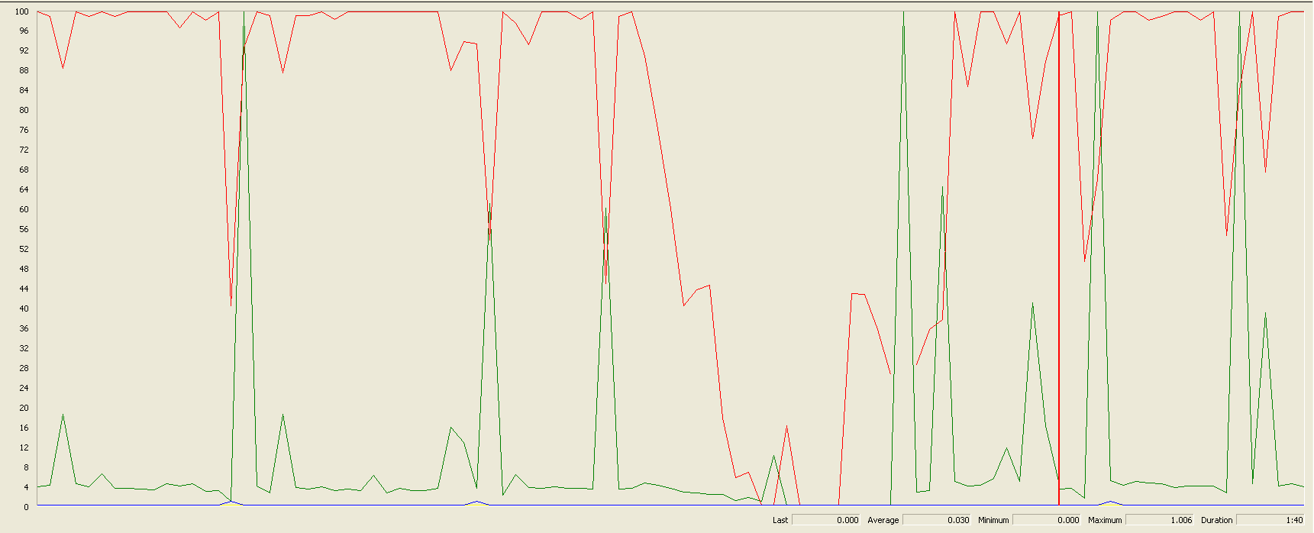

Again we can see that the CPU is always being used while the disk usage has some peaks at times.

## Delete

Sequence:

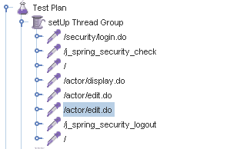

Aggregate Report:



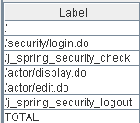

Thread properties:

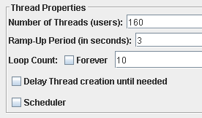

Graph Results:

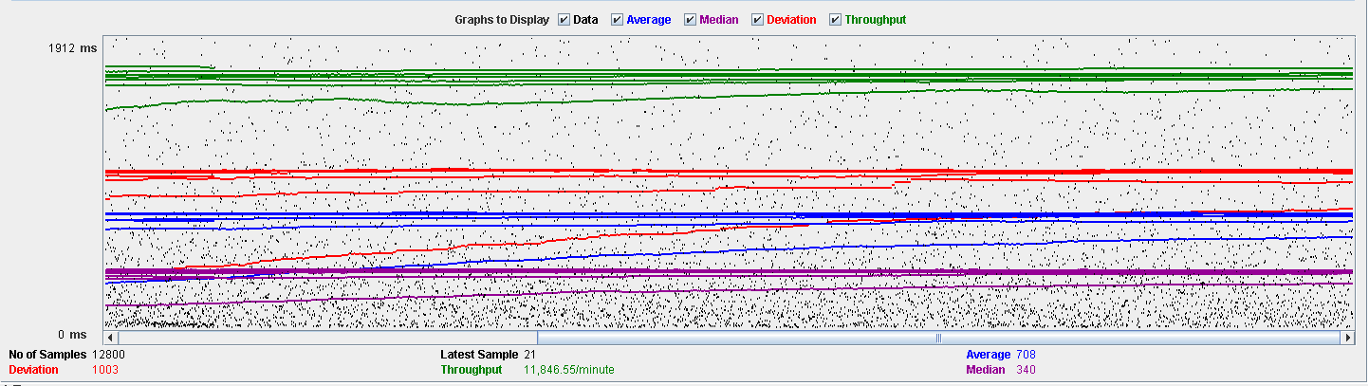

Performance Results:

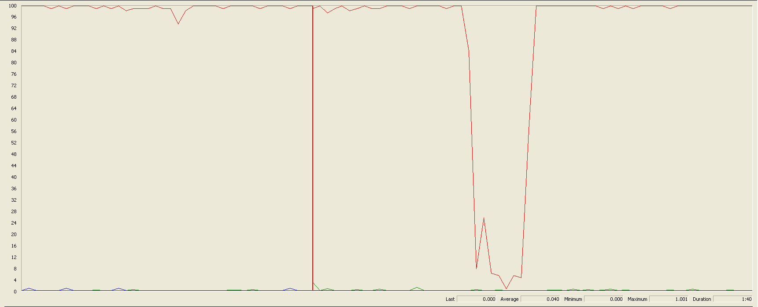

Again we can see that the CPU is always being used while the disk usage has different peaks.

## Conclusion

The test was performed using:

CPU: i7 7700hq (2 cores in the virtual machine)

RAM: 4 GB (virtual machine)

For this use case we can say that the limitation occurs during the creation process, being the maximum of concurrent users is 90.

# Vehicle

## Create

Sequence:

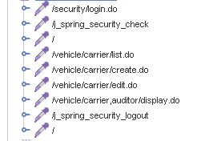

Aggregate Report:

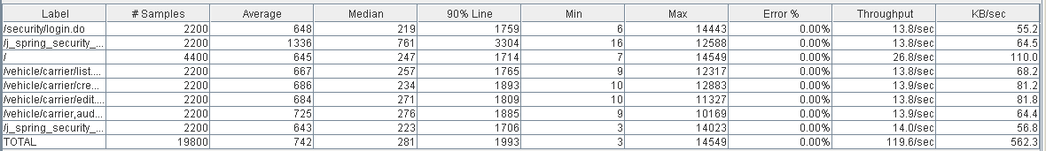



Thread properties:

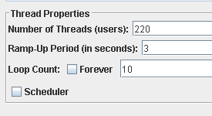

Graph Results:

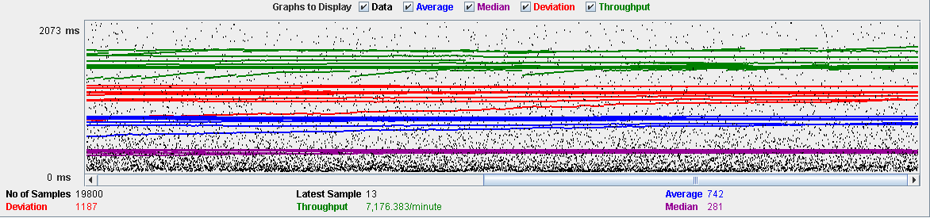

Performance Results:

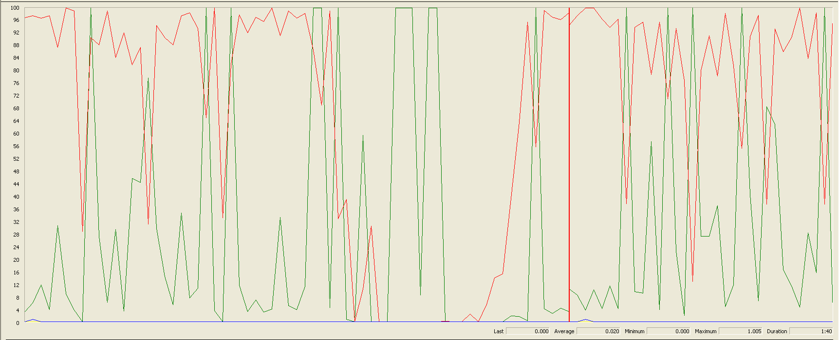

The CPU was always at its limit while the disk usage has many peaks.

## Edit

Sequence:



Aggregate Report: 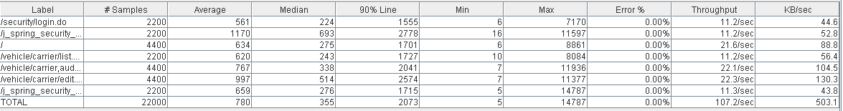



Thread properties:

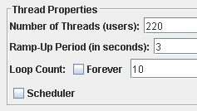

Graph Results:

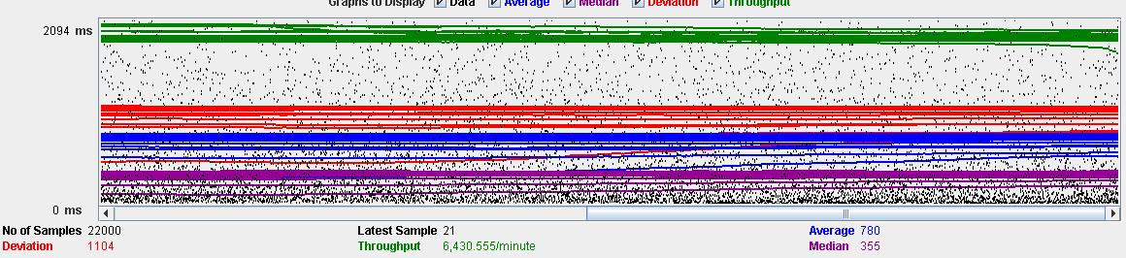

Performance Results:

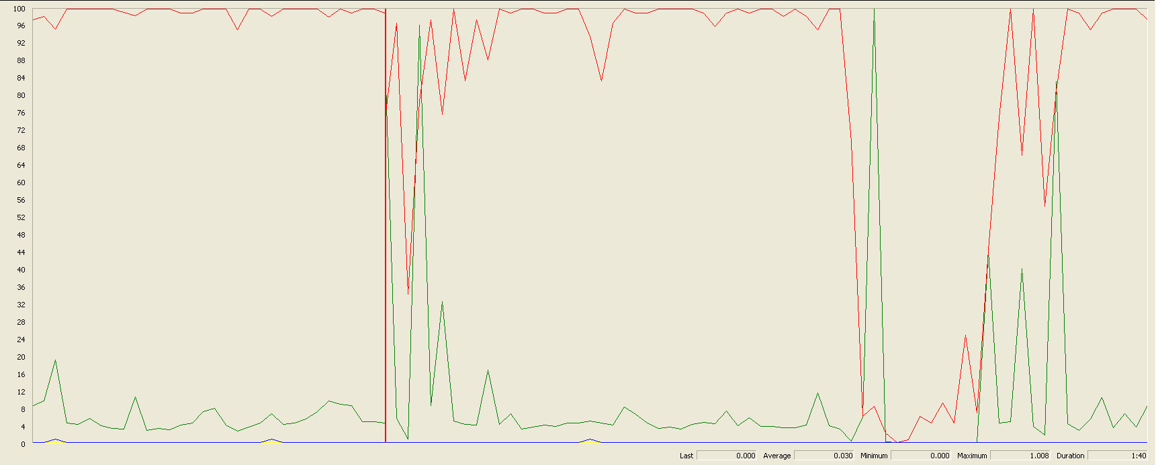

Again we can see that the CPU is always being used while the disk usage has high peaks at times.

## Delete

Sequence:

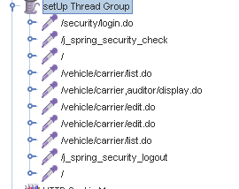

Aggregate Report:

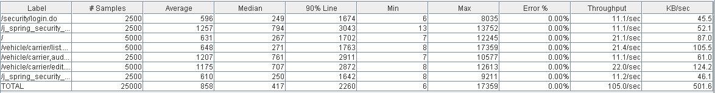



Thread properties:

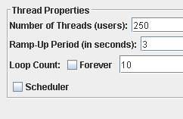

Graph Results:

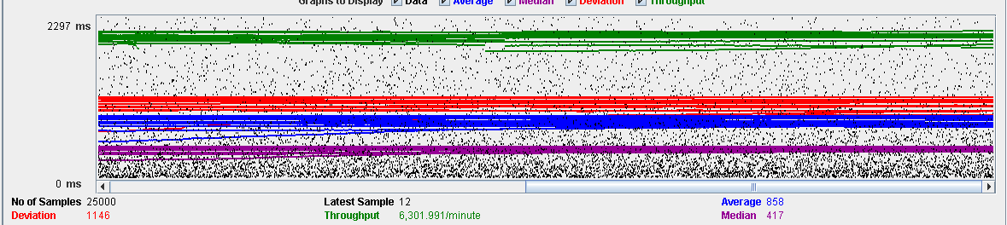

Performance Results:

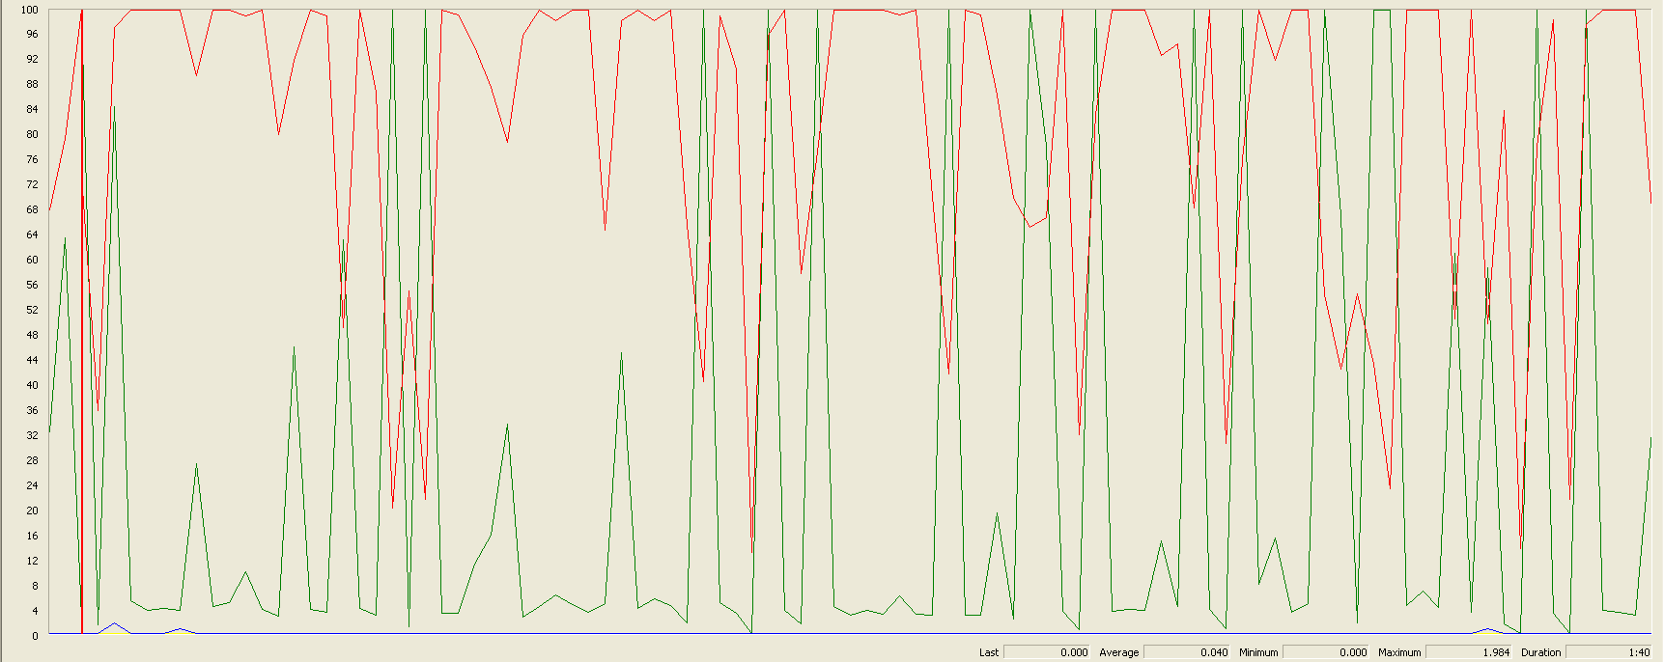

Again we can see that the CPU is always being used while the disk usage has many different peaks.

## Conclusion

The test was performed using:

CPU: i7 7700hq (2 cores in the virtual machine)

RAM: 4 GB (virtual machine)

For this use case we can say that the limitation occurs during the creation process, being the maximum of concurrent users 220.

# Solicitation

## Create

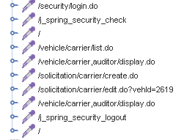

Aggregate Report:

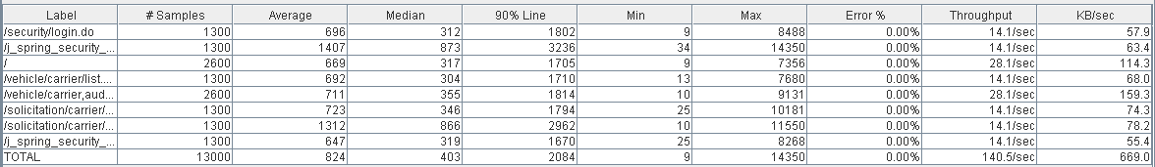

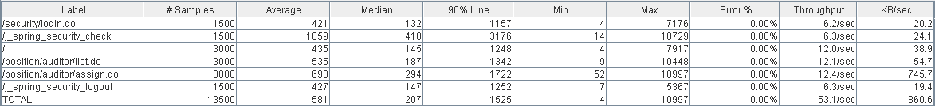

Thread properties:

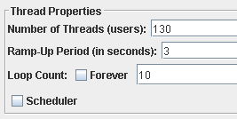

Graph Results:

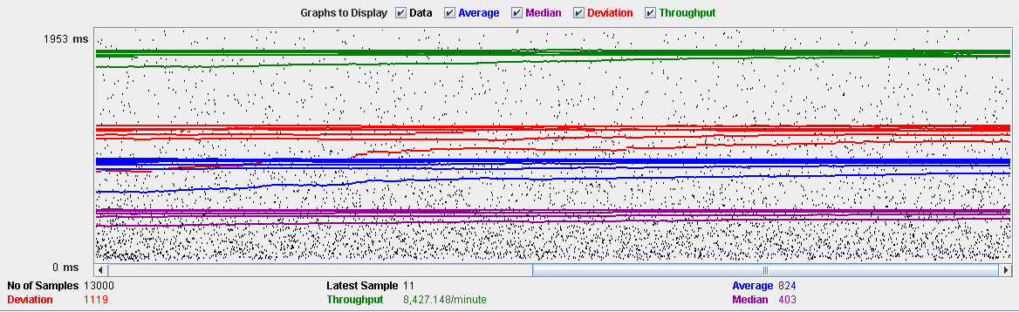

Performance Results:

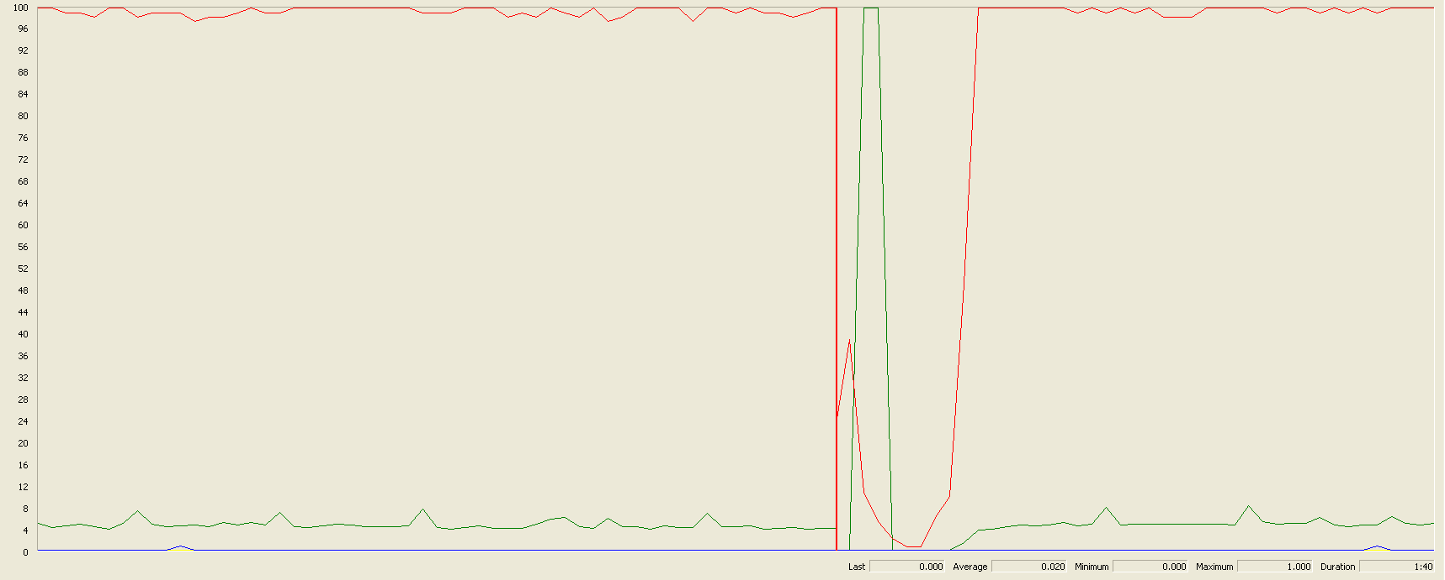

The CPU was always at its limit while the disk usage showed some peaks.

## Edit

Sequence:

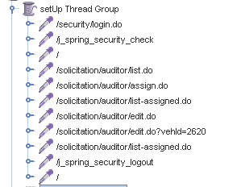

Aggregate Report:

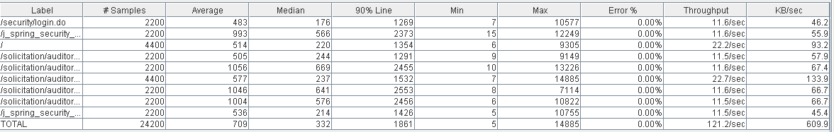

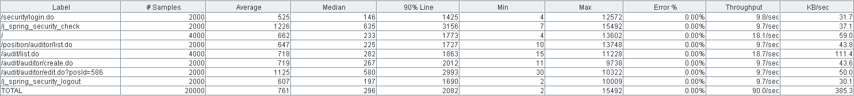

Thread properties:

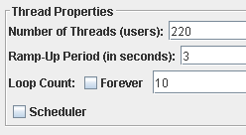

Graph Results:

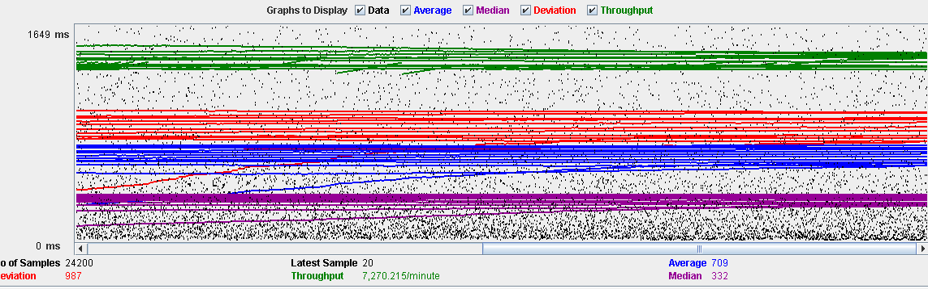

Performance Results:

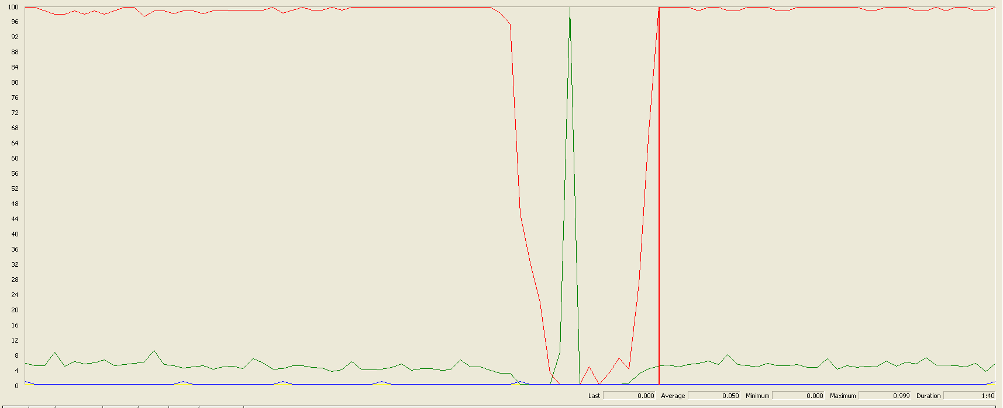

The CPU was always at its limit in various points of the execution while the disk usage showed a big peak.

## Delete

Sequence:

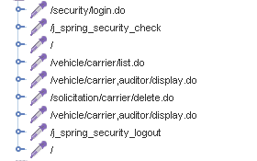

Aggregate Report:

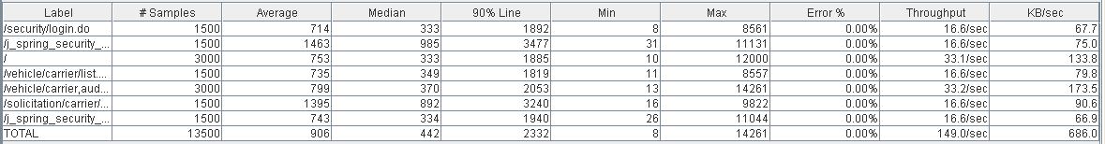

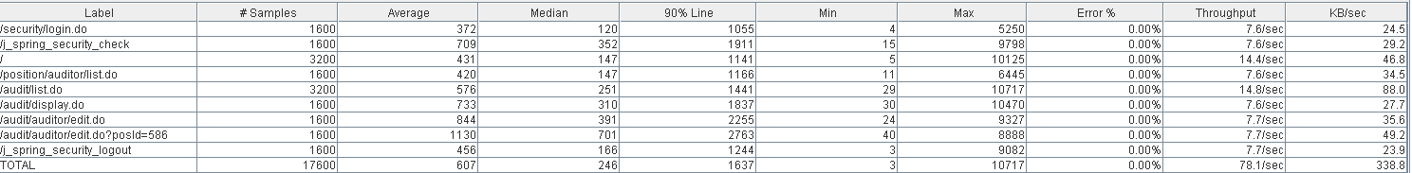

Thread properties:

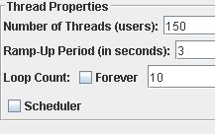

Graph Results:

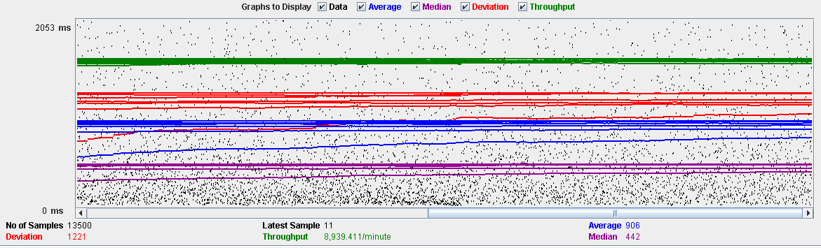

Performance Results:

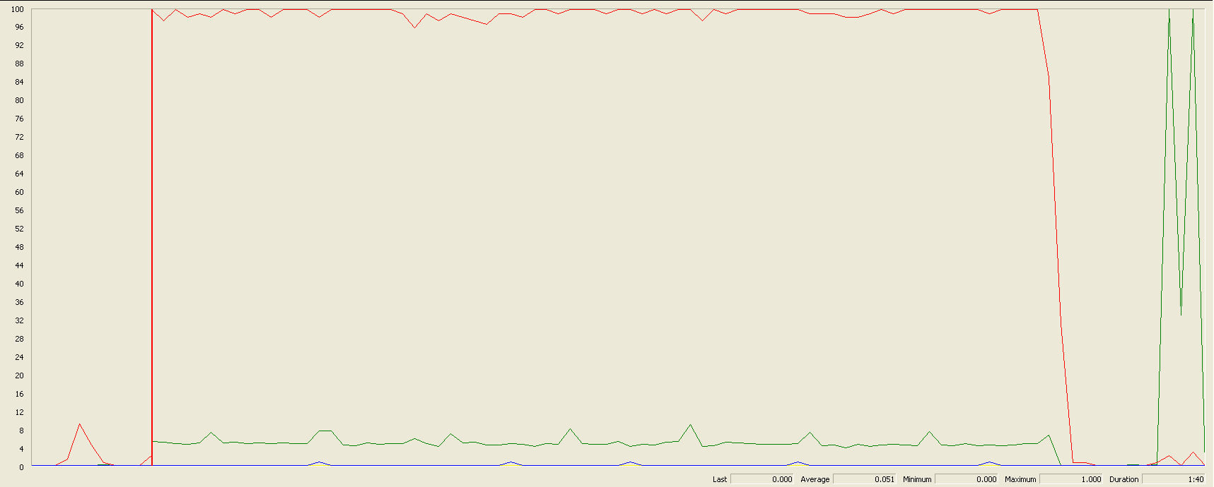

The CPU was always at its limit while the disk usage showed low peaks.

## Conclusion

The test was performed using:

CPU: i7 6700hq (2 cores in the virtual machine)

RAM: 4 GB (virtual machine)

For this use case we can say that the limitation occurs during the assign process, being the maximum of concurrent users 130.

# Sponsorship

## Create

Sequence:

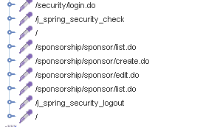

Aggregate Report:

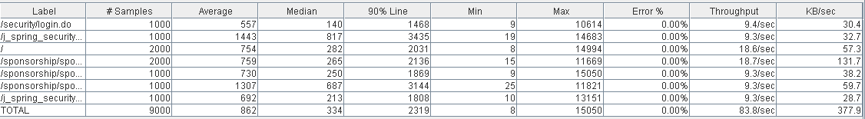

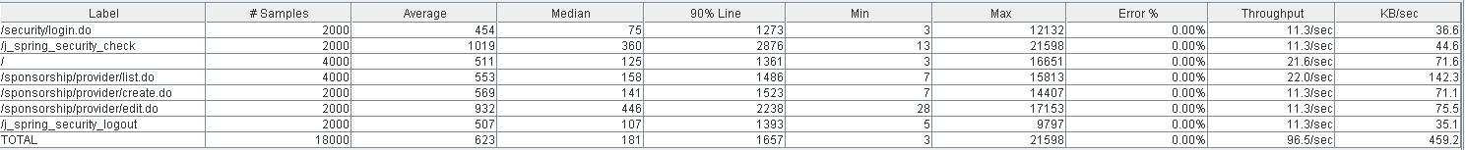

Thread properties:

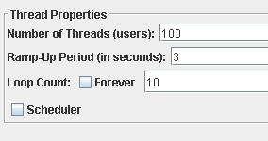

Graph Results:

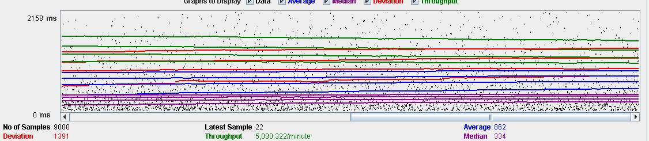

Performance Results:

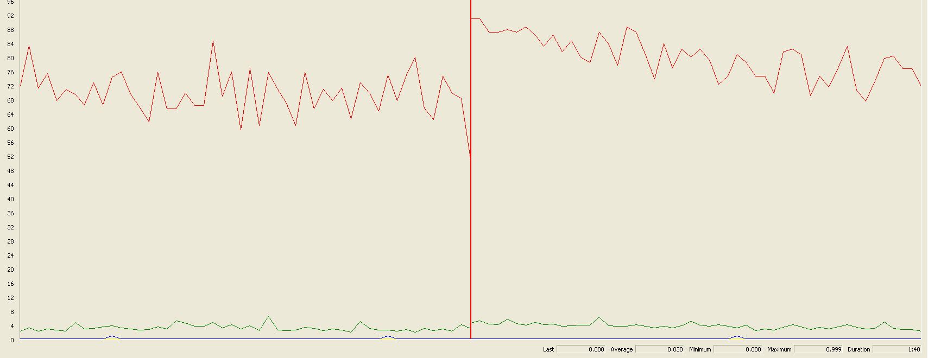

The CPU was always at its limit while the disk usage showed low peaks.

## Edit

Sequence:

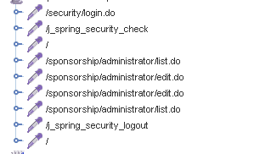

Aggregate Report:

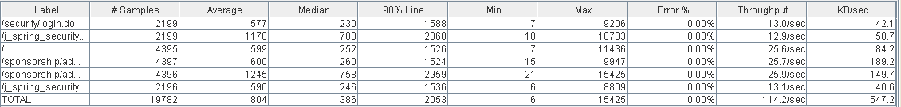



Thread properties:

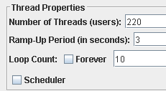

Graph Results:

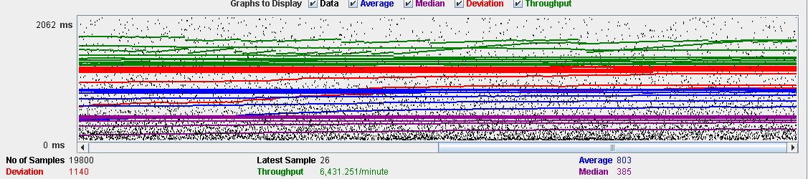

Performance Results:

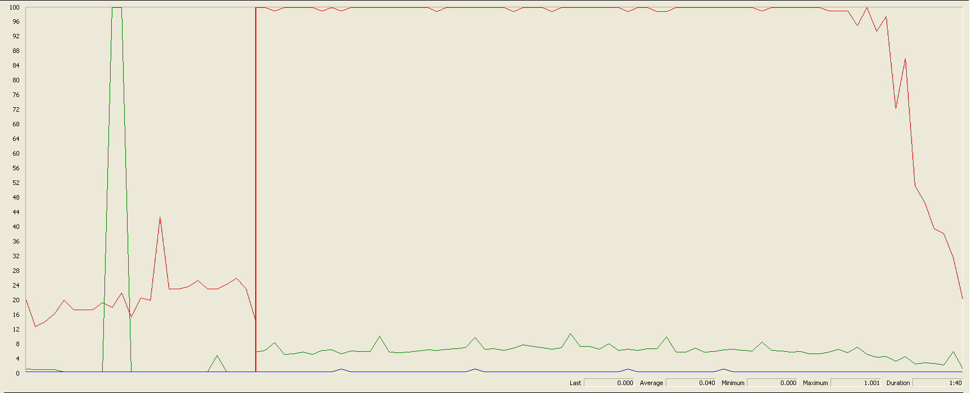

The CPU was always at its limit.

## Delete

Sequence:

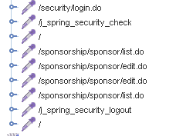

Aggregate Report:

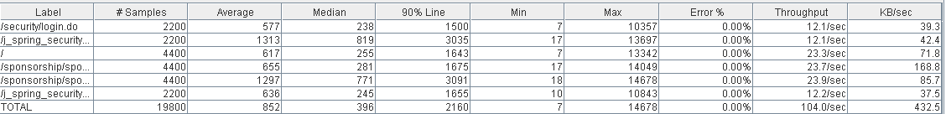



Thread properties:

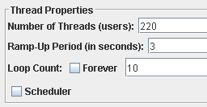

Graph Results:

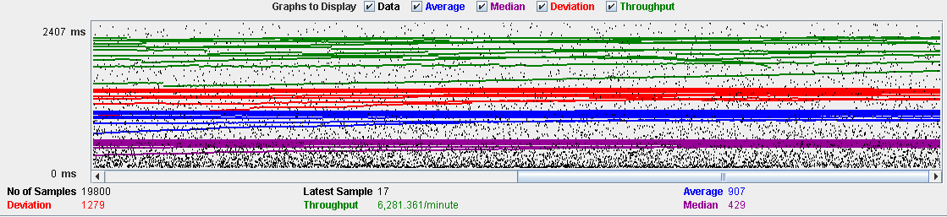

Performance Results:

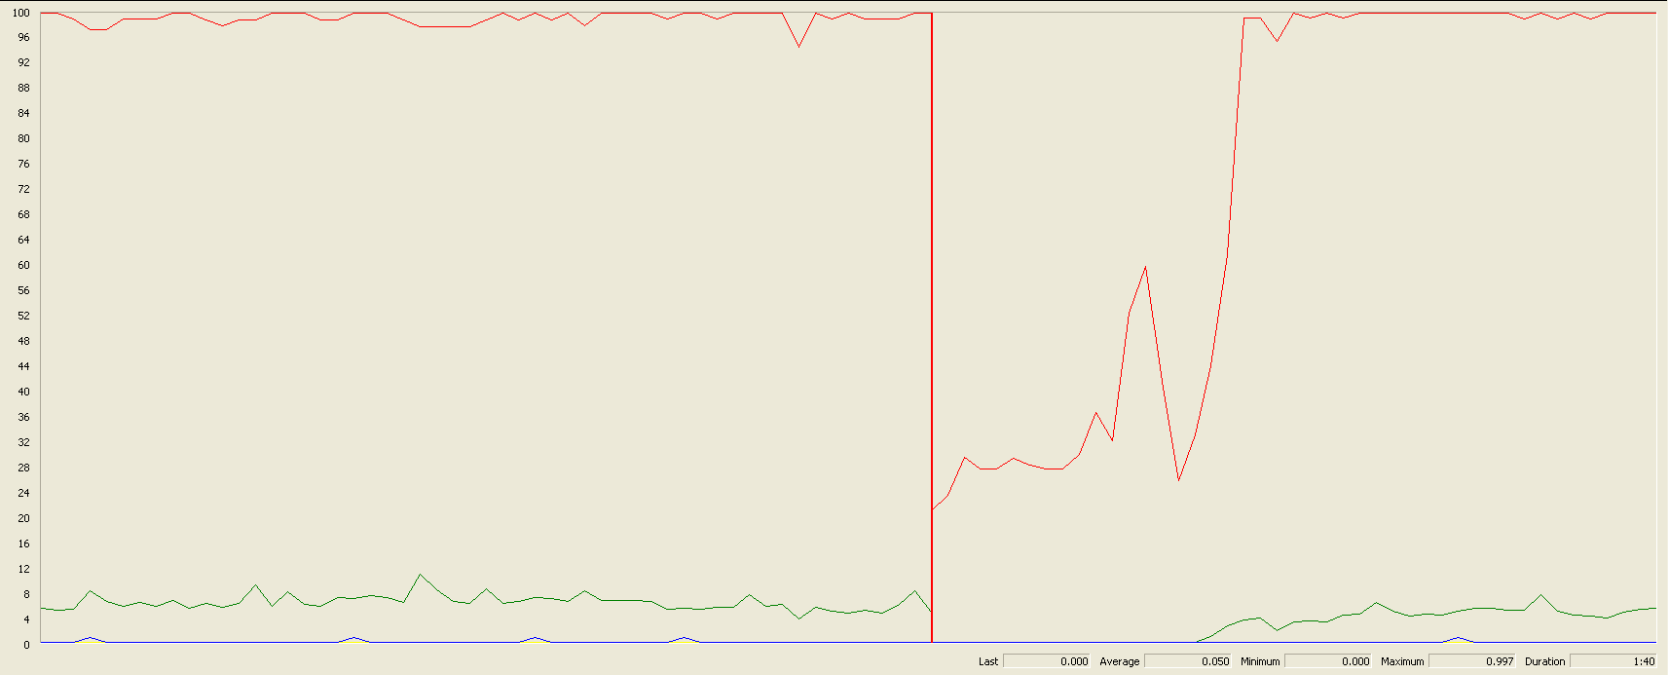

The CPU was always at its limit and had disk usage low peaks.

## Conclusion

The test was performed using:

CPU: i7 6700hq (2 cores in the virtual machine)

RAM: 4 GB (virtual machine)

For this use case we can say that the limitation occurs during the create process, being the maximum of concurrent users 100.

# Fare

## Create

Sequence:

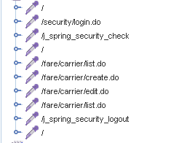

Aggregate Report:

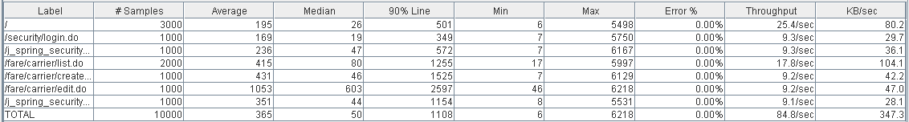

  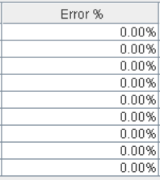

Thread properties:

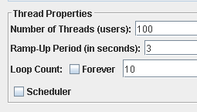

Graph Results:

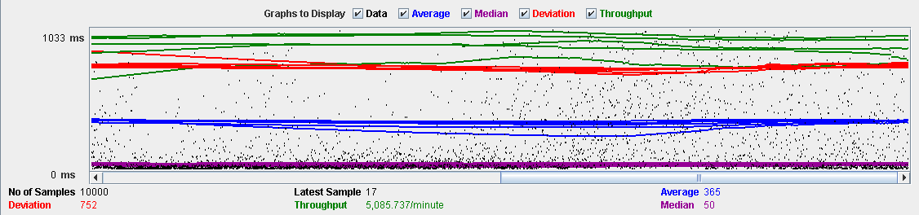

Performance Results:

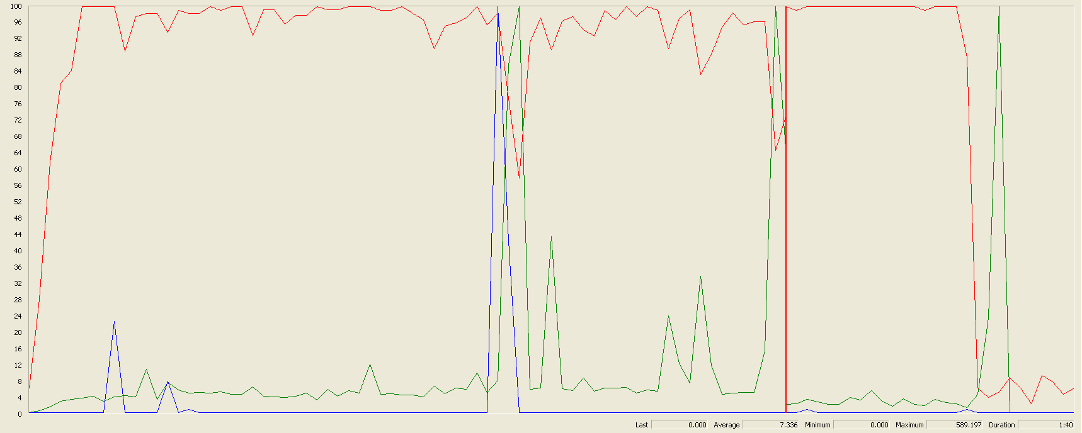

The CPU was always at its limit while the disk usage has a lot of peaks.

## Edit

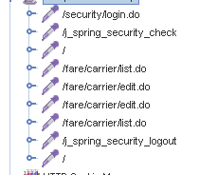Sequence:

Aggregate Report:

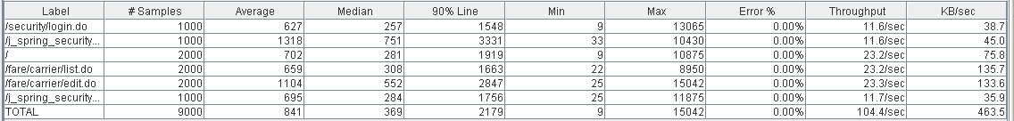

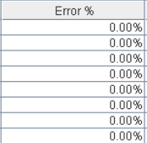

Thread properties:

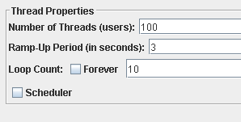

Graph Results:

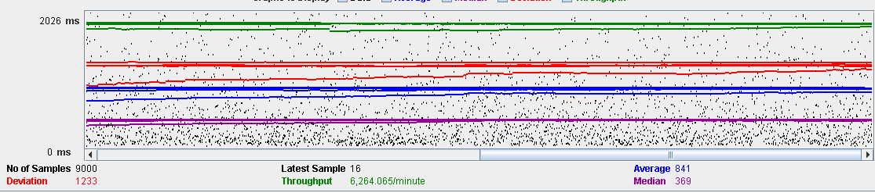

Performance Results:

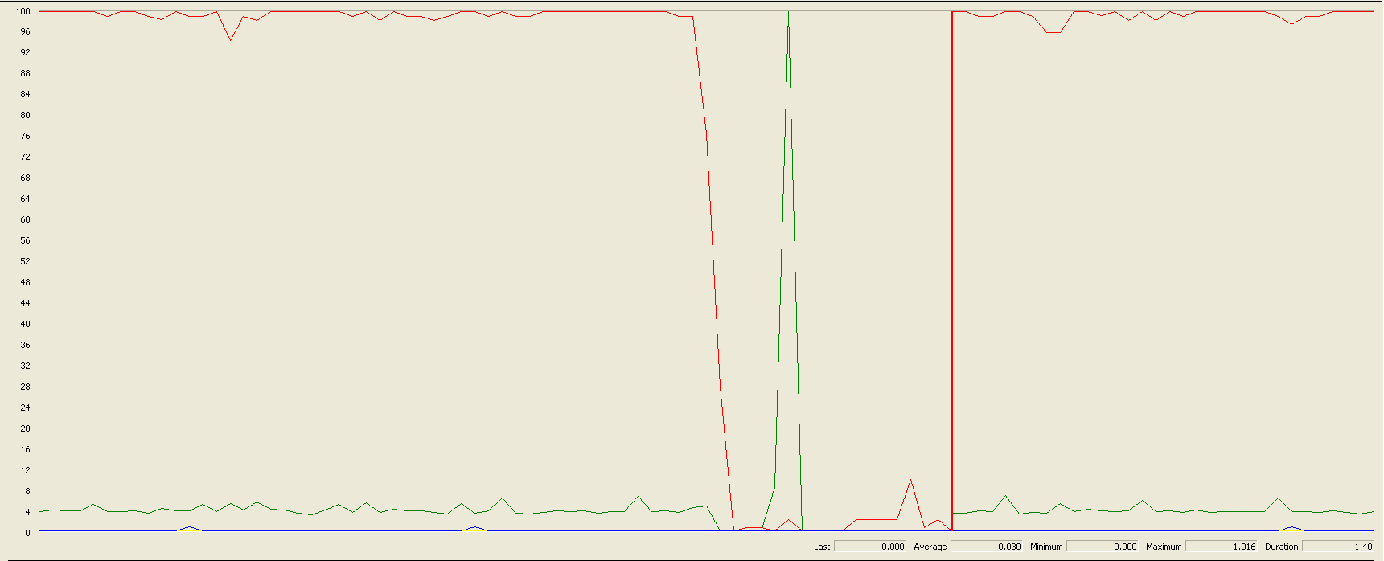

Again we can see that the CPU is always being used and disk usage had some peaks.

## Delete

Sequence:

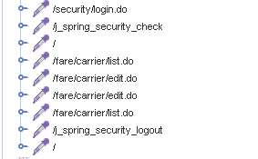

Aggregate Report:

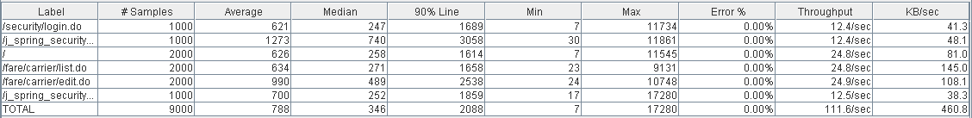

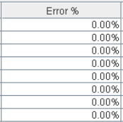

Thread properties:

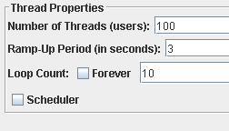

Graph Results:

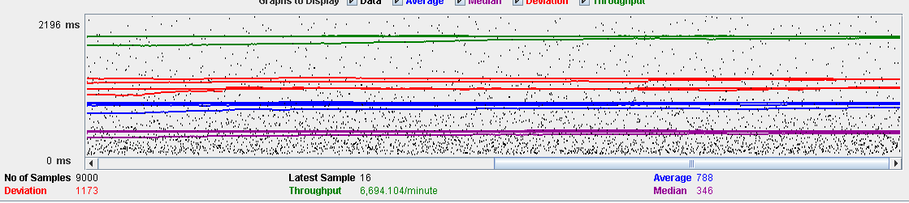

Performance Results:

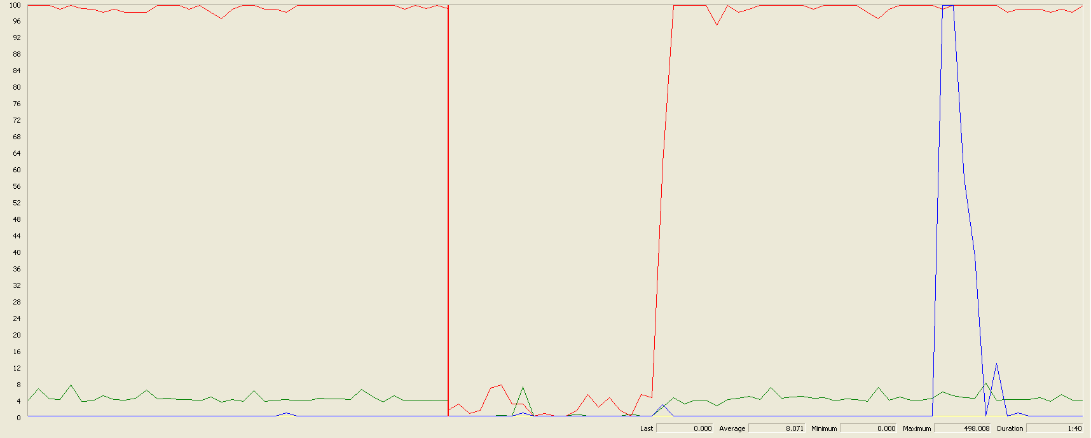

Again we can see that the CPU is always being used while the disk usage and network have different peaks.

## Conclusion

The test was performed using:

CPU: i5 7300hq (2 cores in the virtual machine)

RAM: 2 GB (virtual machine)

For this use case we can say that the limitation occurs during with all the process, being the maximum of concurrent users 100.

# Conclusion of the performance

As we can see in the tests above, the limitations of our system are in the message system, particularly in the method of execute every function available in the dashboard (30 concurrent users). We think that this may be a bit unrealistic, because in a real environment won’t be many administrators using that functions. Due that, we consider that the limit of concurrent users for our system is 54 (creating a request).